# **I**ndex

|  |  |  |  |
| --- | --- | --- | --- |
| **Chapter No.** |  | **Details** | **Page No.** |
| **1.** |  | **Introduction** |  |
|  | 1.1 | Company Profile/ Client Profile | 5 |
|  | 1.2 | Abstract | 6 |
|  | 1.3 | Existing System and Need for System | 7 |
|  | 1.4 | Scope of System | 9 |
|  | 1.5 | Operating Environment – Hardware and Software | 10 |
|  | 1.6 | Brief Description of Technology Used | 11 |
|  |  | 1.6.1 Operating System Used (Windows) | 12 |
|  |  | 1.6.2 Software used to build an application | 13 |
| **2.** |  | **Proposed System** |  |
|  | 2.1 | Feasibility Study | 14 |
|  | 2.2 | Objectives of Proposed System | 18 |
|  | 2.3 | User of System | 20 |
| **3.** |  | **Analysis and Design** |  |
|  | 3.1 | System Requirements (Functional and Non-Functional requirements) | 22 |
|  | 3.2 | Entity Relationship Diagram (ERD) |  |
|  | 3.3 | Use Case Diagrams | 24 |
|  | 3.4 | Class Diagram | 16 |
|  | 3.5 | Activity Diagram | 17 |
|  | 3.6 | Module Hierarchy Diagram |  |
|  | 3.7 | Deployment Diagram |  |
|  | 3.8 | Table Structure | 19 |
|  | 3.9 | Data Dictionary | 20 |
|  | 3.10 | Sample Input and Output Screens | 21 |
| **4.** |  | **Coding** |  |
|  | 4.1 | Algorithms |  |
|  | 4.2 | Code Snippets | 32 |
| **5.** |  | **Testing** |  |
|  | 5.1 | Test Strategy | 49 |
|  | 5.2 | Unit Test Plan | 52 |
|  | 5.3 | Acceptance Test Plan | 56 |
|  | 5.4 | Test Case | 60 |
| **6.** |  | **Limitations of Proposed System** | **63** |
| **7.** |  | **Proposed Enhancements** | **65** |
| **8.** |  | **Conclusion** | **69** |
| **9.** |  | **Bibliography** | **70** |
| **11.** |  | **Annexure** | **71** |

# **I**nternship Company Profile:

|  |  |
| --- | --- |
| Company background-Organization | Elite Softwares |
| Activities/Scope | We at Elite Softwares Pune based Software Company since 2011 with more than 1000 Clients and we developed our own products as Educational ERP, CRM Software, Recruitment Portal and CET Portal for mock test. We Specialize and we work only for School and College ERP (Enterprise Resource Planning) Software and Technical Workshops for Entrepreneurship Development.  We are Budding company whose sole purpose is 'SERVICE'. Our aim is to provide dynamic IT solution to our education domain clients and of course self-employment workshops for students.  Using our School and College ERP Products, we are trying to automate education domain where starts with enquiry to generate Leaving Certificate all in one solution we provide.  Efficiency is in our veins and we strive for excellence.  We are a software providing company which takes wholesome responsibility; that includes all basic information, whereabouts, branch offices, contacts, requirements, basically all rolled into one. |
| Objective of Study | * Learning web development * Improving Python programming skills * Gaining experience with database management * Understanding software development life cycle * Building a portfolio |
| Supervisor Details:  (Name,Designation,Company Name,Email_Id,Contact number) | Mr. Swami Panjala  Founder and CEO  [swami@elitesoftwares.co.in](mailto:swami@elitesoftwares.co.in)  9096622683  <https://www.elitesoftwares.co.in> |

# **I**ntroduction Abstract:

The Freelancer Indian Housewife Portal is a dedicated digital platform aimed at empowering Indian housewives by connecting them with freelance work opportunities across various industries.

Housewives embody a profound form of empowerment, often overlooked yet essential. Their nurturing roles within the household serve as the backbone of families and communities. Through their dedication, they foster an environment where loved ones thrive and dreams are nurtured.

* Empowerment for housewives lies in the recognition of their invaluable contributions, granting them agency and respect.
* Empowering housewives means acknowledging their choices, aspirations, and rights, ensuring they have access to opportunities for personal growth and fulfilment.

Women's empowerment begins at home, where housewives serve as catalysts for change, shaping future generations with wisdom and grace.

In today's digital era, technology has transformed every aspect of our lives, including how people work and earn a living. Despite this digital revolution, a significant portion of the population — particularly Indian housewives — remains underrepresented in the workforce. While many women possess valuable skills and education, social responsibilities, cultural expectations, or lack of access to professional networks often prevent them from participating in traditional employment structures. This results in a vast pool of untapped talent that, if properly utilized, could contribute significantly to household incomes and the national economy.

This project also aligns with broader national goals such as women empowerment, digital inclusion, and the promotion of entrepreneurship. It supports the idea that true economic progress is only possible when women are active participants in the economy. The Freelancer Indian Housewife Portal is more than just a job platform — it is a movement to recognize, respect, and reward the silent potential within millions of Indian homes.

Python-Django is a high-level web framework built in Python. Django provides a convenient way to build web applications quickly, with its clean and pragmatic design philosophy. Django follows the Model-View-Template (MVT) pattern, which is similar to the Model-View-Controller (MVC) pattern but with some differences, making it easier to develop web applications.

A Python-Django internship can be a great way to learn web development with Python, and gain hands-on experience building real-world web applications. During the internship, you are likely to learn how to set up the Django framework, including creating virtual environments, installing dependencies, and configuring database settings. You will also learn how to build web applications with Django, including creating models, views, and templates, working with URL routing, handling forms and user inputs, and integrating third-party libraries and APIs to enhance the functionality of the application.

# **E**xisting **S**ystem and **N**eed for **S**ystem

# **Title:-**

# **Freelancer House Wife Portal:**

# **Existing System:**

| **Aspect** | **How it was handled before** |
| --- | --- |
| **Housewife Registration** | Manual collection of details on paper forms, Excel sheets, or Google Forms. |
| **Freelancer Login** | No login system — housewives would directly contact coordinators via phone, WhatsApp, or email. |
| **Work Assignment** | Work would be assigned manually via phone calls, emails, or messaging apps like WhatsApp. |
| **Work Status Tracking** | Admins would manually ask for updates via calls/messages and maintain Excel sheets. |
| **Admin Management** | Admin would maintain huge Excel files or physical files to track registrations and assignments. |
| **Report Generation** | Reports manually prepared using Excel (filtering, sorting, manually updating statuses). |
| **Password / Authentication** | No system of password protection. Admin/freelancer communications were informal. |
| **Communication** | Mostly by phone, emails, or personal visits — very slow and inefficient. |

# 🔥 **Problems in the Old System:**

* Data loss risk (physical files can be lost, Excel files can be deleted)
* No real-time work assignment tracking
* Delays in assigning tasks and collecting completed work
* No security for freelancer data
* Very poor scalability (managing 10 freelancers vs 1000 freelancers — almost impossible manually)
* Time consuming and labor intensive for admin and freelancers both
* No proper report generation or analysis
* Poor freelancer engagement and motivation (no dashboard, no visibility)

# Therefore, Need for New Portal

Your **Freelancer Housewife Portal** automates and solves all these problems by:

* Centralizing data
* Giving freelancers self-login access
* Allowing admins to assign and monitor work easily
* Fast report generation
* Secure authentication system

# **Need for System:-**

# In India, a large percentage of women, particularly housewives, remain outside the formal workforce due to social, cultural, and personal constraints.

# Despite being educated, talented, and skilled in various domains such as teaching, writing, arts and crafts, cooking, stitching, and more, these women are often confined to household responsibilities. As a result, their skills remain underutilized, and they miss out on the opportunity to contribute financially to their families and society at large.

# One of the major reasons behind this issue is the lack of accessible, flexible, and home-based employment opportunities tailored to the needs and limitations of housewives. Traditional job markets typically require fixed hours, commuting, and external commitments — all of which may not be feasible for women managing households, children, or elderly care. Even when opportunities exist in the form of freelancing or remote work, most platforms are not specifically designed for housewives. They may be too complex, highly competitive, or limited to specific sectors like IT, leaving many talented women behind.

# Additionally, lack of digital literacy, language barriers, and limited awareness of available opportunities further widen the gap. Many housewives may not know how to build a professional profile, write a resume, or apply for online jobs. Even those who attempt to enter the freelancing space often face challenges such as lack of guidance, fear of online fraud, or unclear payment processes.

# **Objective:-**

# Therefore, there is a strong need for a specialized platform that:

# Understands the unique lifestyle and limitations of Indian housewives, Provides user-friendly access to remote and freelance job opportunities, Offers learning and skill-development resources, Facilitates safe communication and secure payments, And creates a supportive community for confidence-building and networking.

# **S**cope of **S**ystem:

# **1. Services Offered:**

# Freelancer housewives may undertake projects in the following areas:

# **Content Writing**: Articles, blogs, product descriptions, resumes, etc.

# **Graphic Design**: Social media posts, logos, posters, presentations.

# **Virtual Assistance**: Data entry, customer support, scheduling, research.

# **Digital Marketing**: Social media management, email campaigns, SEO.

# **Online Tutoring**: Academic coaching, spoken English, skills training.

# **Crafts & Home-Based Products**: Handmade goods, food items, decor.

# **Translation/Transcription**: Translating documents, transcribing audio/video.

# **Tech Support**: Basic website updates, app testing, software feedback.

# **2. Work Process:**

# Receive project brief from client or platform

# Clarify scope, deadlines, and deliverables

# Execute work using appropriate tools/software

# Submit drafts, accept feedback, make revisions

# Deliver final product within agreed timeline

# The future scope of freelancing for housewives is vast and highly promising, especially in a world increasingly driven by remote work and digital connectivity. As more businesses shift to outsourcing and digital collaboration, the demand for skilled freelancers continues to grow. Housewives can tap into this evolving market by offering services that align with their talents, whether it’s writing, design, marketing, virtual assistance, or even selling handmade products. This model allows them to maintain work-life balance, gain financial independence, and contribute meaningfully to their household income without stepping away from their family responsibilities.

# The flexibility of freelancing also supports continuous learning, enabling housewives to upskill in various digital tools and global trends, thereby enhancing their long-term employability and career growth. As society increasingly supports women’s empowerment and inclusive economic participation, freelancing stands out as a sustainable, dignified, and scalable opportunity for housewives seeking both purpose and profit.

# **Operating Environment – Hardware and Software:**

**1. Hardware Requirements**

| **Type** | **Minimum Requirement** | **Recommended Requirement** |
| --- | --- | --- |
| Server | 4 GB RAM, 2 Core CPU, 100 GB HDD | 8 GB RAM, 4 Core CPU, 250 GB SSD |
| Client (User PC/Mobile) | 2 GB RAM, Dual Core Processor, Internet access | 4 GB RAM, Quad Core Processor, Good internet connection |
| Devices Supported | Desktop, Laptop, Tablet, Mobile Phone | Desktop, Laptop, Tablet, Mobile Phone |

✅ Since it's a web portal, **no heavy hardware** is needed for users — even low-end smartphones can access it if responsive.

**2. Software Requirements**

| **Component** | **Details** |
| --- | --- |
| Operating System (Server) | Linux (Ubuntu 20.04 LTS or later) or Windows Server 2016+ |
| Web Server | IIS if using Windows |
| Backend | Python Django 3.2+ |
| Database | SQLite |
| Frontend | HTML5, CSS3, JavaScript and Bootstrap 5 for design responsiveness |
| Browser Support | Chrome, Firefox, Edge, Safari (latest versions) |
| Additional Libraries/Frameworks | Bootstrap |
| SSL Certificate | Required (HTTPS) for security |

**Brief Description of Technology Used:**

**1. Frontend Technologies**

* **HTML5**:  
  Used to structure the web pages and forms. Provides semantic elements that enhance SEO and accessibility.
* **CSS3**:  
  Applied for styling the portal — including layout design, responsive behavior, and visual enhancements.
* **JavaScript**:  
  Enables interactive elements like form validation, dynamic content updates, and enhancing user experience.
* **Bootstrap 5** *(Optional but recommended)*:  
  A responsive CSS framework that helps in creating a mobile-friendly, consistent, and professional-looking design with minimal custom CSS effort.

**2. Backend Technologies**

* **Python Django Framework**:  
  A high-level Python web framework that promotes rapid development and clean, pragmatic design. Django provides built-in modules for authentication, admin panel, ORM (Object-Relational Mapping), and security features like CSRF protection, making it ideal for building a secure Freelancer Housewife Portal.

**3. Database**

* **SQLite**:  
  A lightweight, file-based relational database used for storing user registrations, freelancer login credentials, assignment data, and admin records.
  + Perfect for small to medium-sized applications.
  + Requires no separate server setup.
  + Fast and efficient for development and production when the user base is manageable.

**4. Web Server and Hosting**

* **VPS (Virtual Private Server)**:  
  The application is hosted on a VPS, providing dedicated resources like CPU, RAM, and storage.  
  VPS hosting ensures better performance, security, and scalability compared to shared hosting, making it ideal for handling freelancer data securely.
* **Gunicorn + Nginx** *(Typical setup for Django apps on VPS)*:
  + Gunicorn acts as the WSGI HTTP server for serving Django applications.
  + Nginx is used as a reverse proxy to handle client requests efficiently and securely.

**5. Security Technologies**

* **HTTPS with SSL Certificates**:  
  Ensures all data transmission between client and server is encrypted and secure.
* **Password Hashing (Django built-in)**:  
  Freelancer and Admin passwords are automatically hashed and stored securely by Django’s authentication system.

**6. Other Tools / Technologies**

* **Visual Studio Code**:  
  Lightweight, powerful code editor used for writing and managing frontend and backend code efficiently.

**1.6.1 Operating System Used (Windows):**

### 1. Development Environment

* **Windows OS Version**: The development of the portal is carried out on machines running various versions of Windows (e.g., Windows 10, Windows 11) based on the developer's preferences.
* **Tools Used on Windows**:
  + **IDE**: Visual Studio Code, PyCharm, or Sublime Text for code editing.
  + **Database**: SQLite (database management and local storage during development).
  + **Version Control**: Git for managing code changes and GitHub or GitLab for collaboration.
  + **Web Browser**: Chrome, Edge, or Firefox for testing and debugging the application.
  + **Command Line**: Windows Command Prompt or PowerShell for running backend services, setting up virtual environments, and managing dependencies using pip (Python package installer).

### 2. Production Environment

* **Windows Server**: The portal can be deployed on a Windows-based server (such as **Windows Server 2016/2019**) with **Internet Information Services (IIS)** for hosting the application, depending on organizational infrastructure.
* **Python and Django Deployment**: Although **Linux** is commonly used for production deployment, it is possible to use Windows for production. Using tools like **WSGI** (Web Server Gateway Interface), the portal can run on a Windows server.

### 3. Testing Environment

* **Local Testing**: Windows is used for testing the system locally before deploying it to production. Developers can test the functionalities using a local server, often managed by Django's built-in development server.
* **Testing Tools**: Tools like **Postman** for API testing, **Selenium** for UI testing, and **PyTest** for unit testing are used to validate the system on a Windows environment.

### Benefits of Using Windows for Development

* **Familiarity**: Windows is a popular operating system for developers, providing a user-friendly interface and compatibility with a wide range of development tools and applications.
* **Support for Development Tools**: Windows supports IDEs and text editors such as PyCharm, Visual Studio Code, and Sublime Text, making it a preferred choice for web development.
* **Versatility**: While many developers use Windows for development, the platform can still be configured to run development tools (such as Python and Django) effectively, even though production deployment might be on a Linux-based server.

This **Windows** operating system-based setup provides a stable, flexible, and easy-to-use development and testing environment for the **Freelancer Housewife Portal** project, ensuring that the development process is smooth and efficient.

**Software Used to Build the Application:**

### 1. Development Software

#### 1.1. Programming Languages

* **Python**: The core programming language used for developing the backend of the portal. Python is known for its simplicity, readability, and wide range of libraries for web development, making it an ideal choice.

#### 1.2. Framework

* **Django**: A Python web framework used to build the server-side logic, handle HTTP requests, manage the database, and provide essential tools for web application development (authentication, routing, etc.).

#### 1.3. Database Management System (DBMS)

* **SQLite**: A lightweight, file-based relational database used for storing user and assignment data in the initial development and testing phases. It is integrated with Django and is ideal for smaller-scale applications.

#### 1.4. Frontend Development Tools

* **HTML5**: The standard markup language for creating web pages and applications. HTML5 is used for structuring content on the frontend.
* **CSS3**: Used to style and layout the web pages, providing the design for the user interface of the portal.
* **JavaScript**: A client-side scripting language used for adding interactivity to the web pages. JavaScript helps in form validation, dynamic content updates, and handling asynchronous requests.
* **Bootstrap**: A CSS framework used for developing responsive and mobile-first web applications. It provides pre-designed templates and components like navigation bars, forms, buttons, and more.

#### 1.6. IDEs (Integrated Development Environments)

* **PyCharm**: A Python-specific IDE used for backend development in Django. It provides features like debugging, testing, and code completion, improving the development workflow.
* **Visual Studio Code (VS Code)**: A versatile code editor used for both backend (Python) and frontend (HTML, CSS, JavaScript) development. It supports extensions for Django and other tools, making it an efficient environment.

**Proposed System - Feasibility Study:**

The **Feasibility Study** for the proposed **Freelancer Housewife Portal** helps in determining whether the project is viable and worth pursuing. It assesses various factors, including technical, operational, and financial aspects, to ensure that the portal will meet the business objectives effectively and efficiently.

### 1. Technical Feasibility

This aspect assesses whether the technology required for building and running the portal is available and feasible to implement.

#### 1.1. Technology Stack

* **Backend Development**: Python and Django framework have been chosen for backend development. Python is a well-established, easy-to-learn language with a wide range of libraries, and Django is a powerful framework that simplifies web application development.
* **Frontend Development**: HTML, CSS, and JavaScript (with libraries like jQuery and Bootstrap) will be used for developing a responsive and interactive user interface. These technologies are widely supported and allow for fast development.
* **Database**: SQLite is chosen for development and testing because of its simplicity and ease of integration with Django. It will be sufficient for the initial phase of the project. For production, a more robust database system such as PostgreSQL or MySQL can be used to handle a larger volume of data.
* **Deployment**: The portal will be hosted on a **Virtual Private Server (VPS)**. The server will run a Windows-based environment, with Nginx or Gunicorn serving the Django application in production.

#### 1.2. Scalability

The architecture is designed to scale as the user base grows. The system uses Django's built-in tools for handling authentication, database management, and routing. It also allows for future integration of more complex features, such as payment gateways or more advanced communication tools between freelancers and employers.

#### 1.3. Security

* **SSL Encryption**: All communication between the user and the portal will be encrypted using SSL certificates, ensuring data security.
* **Authentication**: Django's user authentication system will ensure that users (freelancers and employers) are properly authenticated and authorized.

**Conclusion (Technical Feasibility)**: The technical aspects of the project are highly feasible, and the chosen technology stack is mature, well-documented, and appropriate for the portal's requirements.

### 2. Operational Feasibility

This aspect evaluates whether the organization has the necessary resources to support the system’s development, maintenance, and operation.

#### 2.1. System Users

* **Freelancers**: Housewives with various skills who will register on the portal and apply for assignments.
* **Employers**: Individuals or companies who will post assignments and hire freelancers.
* **Admins**: Administrative users who will manage the system, moderate user activity, and ensure smooth operation.

#### 2.2. Ease of Use

The portal will be designed with a simple, user-friendly interface, making it easy for housewives to register, create profiles, and apply for work. Employers can easily post assignments, view freelancer profiles, and track assignments. Admins can manage users, assignments, and generate reports.

#### 2.3. Training and Support

* **Training for Admins**: Admin users will be trained on how to manage the portal, view reports, and handle data.
* **Customer Support for Freelancers and Employers**: A support system will be provided through email or an integrated ticketing system to resolve any issues faced by users.

**Conclusion (Operational Feasibility)**: The system is operationally feasible as it requires minimal training for the users, and the resources for maintaining the system (e.g., support staff) are manageable.

### 3. Financial Feasibility

This aspect assesses whether the project is financially viable and whether it fits within the budget and timeline allocated for its development and maintenance.

#### 3.1. Development Costs

* **Development Time**: The project is expected to take approximately 3–6 months to fully develop, including backend and frontend development, testing, and deployment.
* **Resources Needed**: The development team will consist of a Python developer (Django), a frontend developer, and a project manager. The costs for these resources will be calculated based on the hourly or monthly rates.
* **Software and Licensing**: The software stack (Python, Django, SQLite) is open-source and free, so there are no software licensing costs. The VPS hosting will incur some monthly costs, which will be part of the operational expenses.

#### 3.2. Operational Costs

* **Server Hosting**: The VPS hosting costs depend on the server specifications (memory, CPU, storage). The expected cost for hosting the application on a VPS is approximately ₹2,000–₹5,000/month, depending on the server capacity.
* **Domain and SSL Certificate**: The domain name registration will incur a cost of ₹500–₹1,500 per year. An SSL certificate can be purchased for around ₹1,000–₹5,000 per year, depending on the provider.
* **Maintenance Costs**: Regular updates, bug fixes, and improvements will incur operational costs, which can be estimated based on the hourly rate of the developers.

#### 3.3. Revenue Model

The portal can generate revenue through:

* **Subscription Fees**: Employers can pay a monthly or annual subscription fee for posting assignments.
* **Commission Fees**: A small commission can be charged on the freelancer’s earnings once they are hired for assignments.
* **Advertisements**: Ads from third parties can be placed on the portal for additional revenue.

**Conclusion (Financial Feasibility)**: The project is financially feasible, and the initial development costs are manageable. The revenue model provides potential for profitability once the portal reaches a sufficient user base.

### 4. Legal Feasibility

This aspect evaluates the legal aspects of the project, ensuring that it complies with laws and regulations.

#### 4.1. Data Privacy

* The portal will need to comply with data protection laws such as **GDPR** (General Data Protection Regulation) or **Indian IT Act** to protect the personal and sensitive data of users (freelancers and employers). User data (name, email, skills, assignments, etc.) will be stored securely and encrypted.

#### 4.2. Payment and Tax Compliance

* If the portal integrates a payment system, it will need to ensure compliance with tax regulations, including the issuance of invoices and tax filings for commission-based revenue.

**Conclusion (Legal Feasibility)**: The legal requirements are straightforward, and the project will be required to implement necessary safeguards for data privacy and tax compliance.

### 5. Conclusion

Based on the feasibility study, the proposed **Freelancer Housewife Portal** is deemed technically, operationally, financially, and legally feasible. The project aligns with the business goals of connecting housewives with flexible freelance opportunities, providing employers with a dedicated platform to find skilled freelancers, and offering potential for sustainable revenue generation.

**Objectives of the Proposed System:**

The **Freelancer Housewife Portal** is designed to empower housewives by providing them with a platform to find flexible freelance opportunities. The system has several key objectives aimed at meeting the needs of both freelancers (housewives) and employers (individuals or companies). Below are the core objectives of the proposed system:

### 1. Empower Housewives with Freelance Opportunities

* **Objective**: To create a platform that connects housewives with freelance work opportunities based on their skills and availability.
* **Description**: The portal allows housewives to register, create detailed profiles, and apply for various freelance assignments across different domains, giving them the flexibility to work from home.

### 2. Facilitate Easy Assignment Posting for Employers

* **Objective**: To enable employers to post freelance assignments easily and efficiently.
* **Description**: Employers (individuals or companies) can sign up on the portal, post job assignments, and filter applications based on specific criteria (such as skills, experience, location, etc.). This simplifies the hiring process for employers.

### 3. Streamline the Freelance Hiring Process

* **Objective**: To provide an efficient workflow for both freelancers and employers during the hiring process.
* **Description**: The system will handle user registration, job posting, assignment application, and status updates in a seamless and intuitive manner. Employers can review freelancer profiles and hire them directly, while freelancers can track their applications and assigned jobs.

### 4. Provide a User-Friendly Interface

* **Objective**: To design a simple, intuitive, and responsive interface for both freelancers and employers.
* **Description**: The portal will offer an easy-to-navigate UI, making it accessible even to users with limited technical knowledge. It will be optimized for both desktop and mobile devices, ensuring that users can access the platform from anywhere.

### 5. Enable Secure User Authentication and Data Protection

* **Objective**: To ensure that all user data is secure and that only authorized users can access the system.
* **Description**: The portal will implement a secure user authentication system, ensuring that only verified freelancers and employers can access the platform. Personal and financial data will be encrypted to ensure privacy and protection against unauthorized access.

### 6. Facilitate Easy Communication Between Freelancers and Employers

* **Objective**: To provide communication tools for freelancers and employers to interact directly.
* **Description**: The portal will enable messaging features for freelancers and employers to discuss project details, timelines, and expectations. This will enhance collaboration and help clarify any doubts before formal agreements are made.

### 7. Implement an Admin Panel for System Management

* **Objective**: To allow administrators to manage the platform effectively.
* **Description**: The admin panel will provide a dashboard where admins can manage user registrations, monitor assignment postings, approve or reject freelancer applications, generate reports, and maintain the overall functionality of the system.

### 8. Provide Reporting and Analytics for Employers and Admins

* **Objective**: To offer insights and reports for employers and admins.
* **Description**: The system will include a reporting feature for both employers and administrators, allowing them to view detailed statistics about assignment postings, applications, hired freelancers, and revenue generation. These insights will help improve decision-making and system management.

### 9. Ensure Scalability for Future Growth

* **Objective**: To design the system to scale as the user base grows.
* **Description**: The system will be built with scalability in mind, allowing for future enhancements, integration of more features (like payment gateways), and support for an increasing number of users without compromising on performance.

### 10. Offer Flexible Payment and Commission Systems

* **Objective**: To facilitate the payment process between freelancers and employers.
* **Description**: While the initial version of the portal may not include direct payment features, the long-term goal is to integrate payment gateways that will allow employers to pay freelancers securely, and the portal to charge a commission fee for every transaction.

**Users of the System:**

The **Freelancer Housewife Portal** involves multiple user roles, each with specific functionalities and responsibilities. Below are the key users of the system:

### 1. Freelancer (Housewife)

The **Freelancer** is the primary user of the portal. This user is typically a housewife looking for freelance work opportunities to earn an income while balancing family responsibilities.

#### Key Responsibilities and Features:

* **Sign Up and Registration**: Freelancers can register on the portal by providing their personal information, skills, and availability.
* **Profile Management**: Freelancers can create and update their profiles, showcasing their skills, experience, and past work.
* **Browse and Apply for Assignments**: Freelancers can view posted assignments and apply for relevant job postings.
* **Receive Notifications**: Freelancers will receive notifications about job status updates, application results, and new assignments.
* **Track Assigned Projects**: They can track the progress and status of assignments they have been hired for.
* **Communication with Employers**: Freelancers can communicate with employers through the platform's messaging system for assignment details, clarifications, etc.

### 2. Employer (Client)

An **Employer** is a person or organization that posts freelance assignments on the portal and hires freelancers for various tasks.

#### Key Responsibilities and Features:

* **Sign Up and Registration**: Employers can register on the platform and provide details about their business or organization.
* **Post Assignments**: Employers can create and post assignments with descriptions, deadlines, and required skills.
* **Browse Freelancer Profiles**: Employers can browse through freelancer profiles to evaluate and select the right candidate for their assignments.
* **Hire Freelancers**: Employers can send offers to freelancers and hire them for the jobs they post.
* **Monitor Project Progress**: Employers can track the progress of the assignments assigned to freelancers and communicate any changes or updates.
* **Provide Feedback and Ratings**: After project completion, employers can provide feedback, ratings, and reviews for freelancers.

### 3. Admin

The **Admin** is a key user role responsible for the overall management, monitoring, and maintenance of the system. The admin ensures that the portal runs smoothly and efficiently and can manage users, assignments, and system settings.

#### Key Responsibilities and Features:

* **User Management**: Admins can manage both freelancer and employer accounts. They can approve, suspend, or delete user accounts based on guidelines.
* **Assignment Moderation**: Admins have the ability to moderate posted assignments to ensure that they meet platform guidelines and are suitable for the portal.
* **Report Generation**: Admins can generate various reports, such as assignment statistics, freelancer activity, user growth, and financial reports (if payments are integrated).
* **System Configuration and Maintenance**: Admins can manage the system settings, ensuring that the portal remains functional, secure, and up to date.
* **Troubleshoot Issues**: Admins handle system issues and resolve disputes or issues between freelancers and employers.

### 4. Support Team (Optional)

A **Support Team** can be part of the system, providing assistance to users (freelancers and employers) in case they encounter issues or require guidance.

#### Key Responsibilities and Features:

* **Customer Support**: The support team addresses user queries, resolves technical issues, and offers guidance on using the portal effectively.
* **Ticket System**: Users (freelancers and employers) can raise support tickets, which the support team handles to ensure smooth platform operation.
* **FAQs and Documentation**: The support team can maintain an up-to-date knowledge base of frequently asked questions (FAQs) and guides to help users navigate the platform.

### Conclusion

The **Freelancer Housewife Portal** caters to four main types of users, each with distinct responsibilities:

* **Freelancer (Housewife)**: Primary user seeking flexible work opportunities.
* **Employer (Client)**: Posts job assignments and hires freelancers.
* **Admin**: Manages and oversees the overall system and user activity.
* **Support Team (Optional)**: Provides assistance to users and ensures smooth operation.

Each user role has specific functionalities designed to facilitate the smooth running of the portal and promote collaboration between freelancers and employers.

**Analysis and Design:**

**System Requirements (Functional and Non-Functional requirements)**

**1. Functional Requirements**

These are the core features and functionalities the system must provide.

**1.1 User Registration & Authentication**

* **Freelancer Registration**:  
  The system must allow housewives (freelancers) to register via a form that captures essential details like name, email, phone number, address, skills, etc.
* **Admin Registration**:  
  Admin users should be able to register via a secure form with required credentials.
* **Login**:  
  Both freelancers and admins must be able to log in using their credentials (email/username and password).

**1.2 Work Assignment Management**

* **Admin Work Assignment**:  
  Admin should be able to create work assignments and assign them to specific freelancers based on skills and availability.
* **Freelancer Work View**:  
  Freelancers should be able to view all assigned tasks, their status, start/end dates, and detailed descriptions.
* **Work Status Updates**:  
  Freelancers can update the status of their work, either marking it as 'In Progress' or 'Completed.'

**1.3 Reporting**

* **Admin Reports**:  
  Admin should be able to generate various reports, including work completion status, freelancer performance, and other essential metrics.
* **Freelancer Activity Tracking**:  
  Admin must be able to track the activities and performance of freelancers.

**1.4 User Management**

* **Freelancer Profile Management**:  
  Freelancers should be able to update their profiles, including their skills, contact information, and availability.
* **Admin Management**:  
  Admin should have the ability to view, edit, and delete freelancer records.

**1.5 Security**

* **Password Encryption**:  
  The system must store passwords securely using hashing algorithms.
* **Access Control**:  
  Admins should have full access, while freelancers should only have access to their profiles and assignments.

**1.6 Notifications**

* **Email Notifications**:  
  The system should send emails to freelancers for new assignments, status updates, and reminders.

**1.7 Audit and Logging**

* **Login History Tracking**:  
  Track every login event, including the user type (admin or freelancer) and timestamp, for security and audit purposes.

**2. Non-Functional Requirements**

These define how the system should perform and its operational qualities.

**2.1 Performance**

* **Response Time**:  
  The system should provide a response time of less than 2 seconds for any user action or request.
* **System Availability**:  
  The portal should be available 99.9% of the time, excluding scheduled maintenance.

**2.2 Scalability**

* **Support for Multiple Freelancers**:  
  The system should handle at least 1000 active freelancer accounts without degradation in performance.
* **Support for Future Growth**:  
  As the number of freelancers or assignments grows, the system should be able to scale horizontally or vertically.

**2.3 Usability**

* **User-Friendly Interface**:  
  The portal should have an intuitive, easy-to-navigate interface, accessible to users with limited technical expertise.
* **Mobile-Friendly Design**:  
  The system must be responsive, allowing freelancers to access it from mobile devices.

**2.4 Security**

* **Data Encryption**:  
  All sensitive data, including passwords and personal details, should be encrypted during transmission and storage.
* **Access Control**:  
  Different access levels (admin vs. freelancer) must be strictly enforced to protect sensitive information.

**2.5 Maintainability**

* **Modular Architecture**:  
  The system should be designed with modularity in mind, making it easy to update, modify, or add new features without affecting other parts of the system.
* **Error Handling**:  
  Proper error messages should be displayed in case of system failure, and logs should be generated for troubleshooting.

**2.6 Compliance**

* **GDPR Compliance**:  
  The system should comply with data privacy regulations, ensuring that user data is protected and managed properly.
* **Legal Documentation**:  
  The system should provide clear terms of service, privacy policies, and other legal documents for users.

**🔥 Summary**

* **Functional Requirements**: Focus on system functionality such as user management, assignment handling, notifications, and reporting.
* **Non-Functional Requirements**: Focus on performance, security, scalability, and compliance, ensuring the system operates efficiently and securely at scale.

# **UML** **D**iagrams

### 1. Use Case Diagram

**Actors:**

* Housewife
* Admin

**Use Cases:**

* Register (Housewife)
* Sign up (Housewife)
* Login (Admin)
* View Registration Records (Admin)
* Generate Reports (Admin)
* Change Password (Admin)

**Whole Project USE Cases Diagram:**

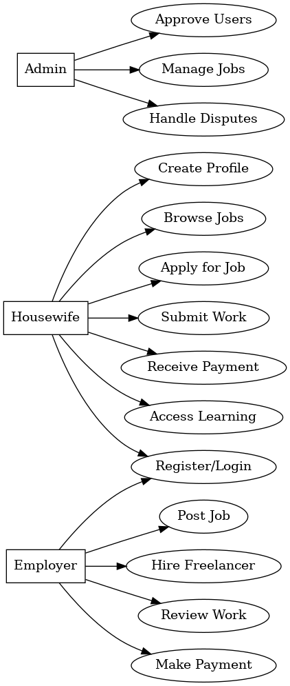

**Class Diagram:**

### 2. Class Diagram (simplified)

plaintext

CopyEdit

+--------------------+

| Housewife |

+--------------------+

| - id |

| - name |

| - email |

| - skills |

| - location |

+--------------------+

| +register() |

| +signUp() |

+--------------------+

+--------------------+

| Admin |

+--------------------+

| - username |

| - password |

+--------------------+

| +login() |

| +fetchRecords() |

| +generateReport() |

| +changePassword() |

+--------------------+

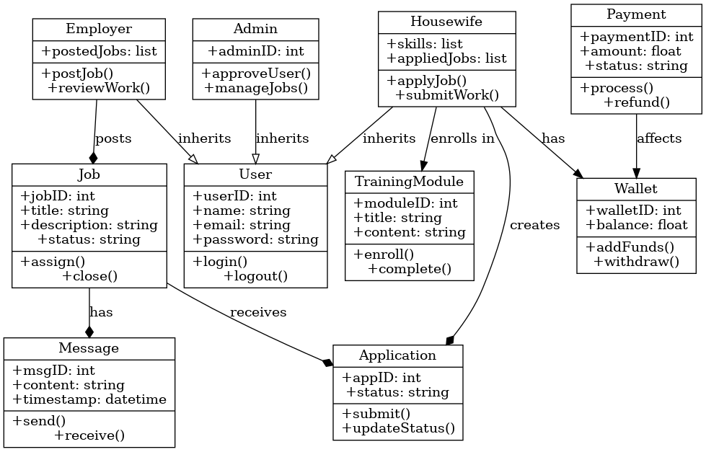

**Activity Diagram:**

### 3. Activity Diagram (Admin Login and Fetch Records Flow)

+------------------+

| Start |

+------------------+

|

v

+------------------+

| Enter credentials|

+------------------+

|

v

+------------------------+

| Validate credentials |

+------------------------+

/ \

Yes No

/ \

v v

+----------------+ +----------------------+

| Show dashboard | | Show error message |

+----------------+ +----------------------+

|

v

+-----------------------+

| Click on "View Data" |

+-----------------------+

|

v

+----------------------------+

| Fetch registration records|

+----------------------------+

|

v

+------------------+

| Display records |

+------------------+

|

v

+--------+

| End |

+--------+

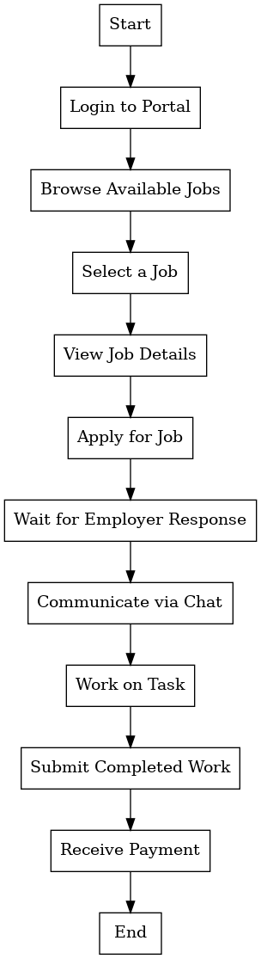

# **Table Structure:**

#### 1.1 Freelancer Table

| **Column Name** | **Data Type** | **Description** |
| --- | --- | --- |
| FreelancerID | INTEGER (PK) | Unique ID for each freelancer (Primary Key). |
| Name | TEXT | Full name of the freelancer. |
| Email | TEXT | Email address of the freelancer (unique). |
| Password | TEXT | Hashed password for authentication. |
| Phone | TEXT | Phone number of the freelancer. |
| Address | TEXT | Home address of the freelancer. |
| Skills | TEXT | List of skills the freelancer specializes in. |
| RegistrationDate | DATETIME | Date and time when the freelancer registered. |
| Status | TEXT | Status of the freelancer (Active/Inactive). |

#### 1.2 Admin Table

| **Column Name** | **Data Type** | **Description** |
| --- | --- | --- |
| AdminID | INTEGER (PK) | Unique ID for each admin (Primary Key). |
| Name | TEXT | Full name of the admin. |
| Email | TEXT | Admin's email address (unique). |
| Password | TEXT | Hashed password for authentication. |

#### 1.3 Assignment Table

| **Column Name** | **Data Type** | **Description** |
| --- | --- | --- |
| AssignmentID | INTEGER (PK) | Unique ID for each assignment (Primary Key). |
| Title | TEXT | Title or name of the assignment. |
| Description | TEXT | Detailed description of the assignment. |
| AssignedTo | INTEGER (FK) | Freelancer ID assigned to the task (Foreign Key). |
| StartDate | DATETIME | The date and time the assignment starts. |
| EndDate | DATETIME | The date and time the assignment ends. |
| Status | TEXT | Current status of the assignment (Pending/In Progress/Completed). |

# **Data Dictionary:**

#### 2.1 Freelancer Table

* **FreelancerID**: Unique identifier for each freelancer. Automatically incremented by SQLite.
* **Name**: Full name of the freelancer.
* **Email**: The freelancer's email address, used for login.
* **Password**: The freelancer's password (hashed) for authentication.
* **Phone**: The freelancer's contact number.
* **Address**: Freelancer's residential address.
* **Skills**: A comma-separated list of skills that the freelancer has, used to match assignments.
* **RegistrationDate**: The timestamp when the freelancer signed up.
* **Status**: Indicates whether the freelancer is active or inactive.

#### 2.2 Admin Table

* **AdminID**: Unique identifier for each admin. Auto-incremented by SQLite.
* **Name**: Full name of the admin.
* **Email**: The admin's email address.
* **Password**: Admin's hashed password for authentication.

#### 2.3 Assignment Table

* **AssignmentID**: Unique identifier for each assignment.
* **Title**: Short title of the assignment.
* **Description**: Detailed description of the assignment.
* **AssignedTo**: The FreelancerID of the freelancer assigned to this task.
* **StartDate**: Date and time the assignment is to start.
* **EndDate**: Date and time the assignment should be completed.
* **Status**: The current status of the assignment (Pending, In Progress, or Completed).

# **P**roject **S**creen **S**hots:

* **Home Page:**

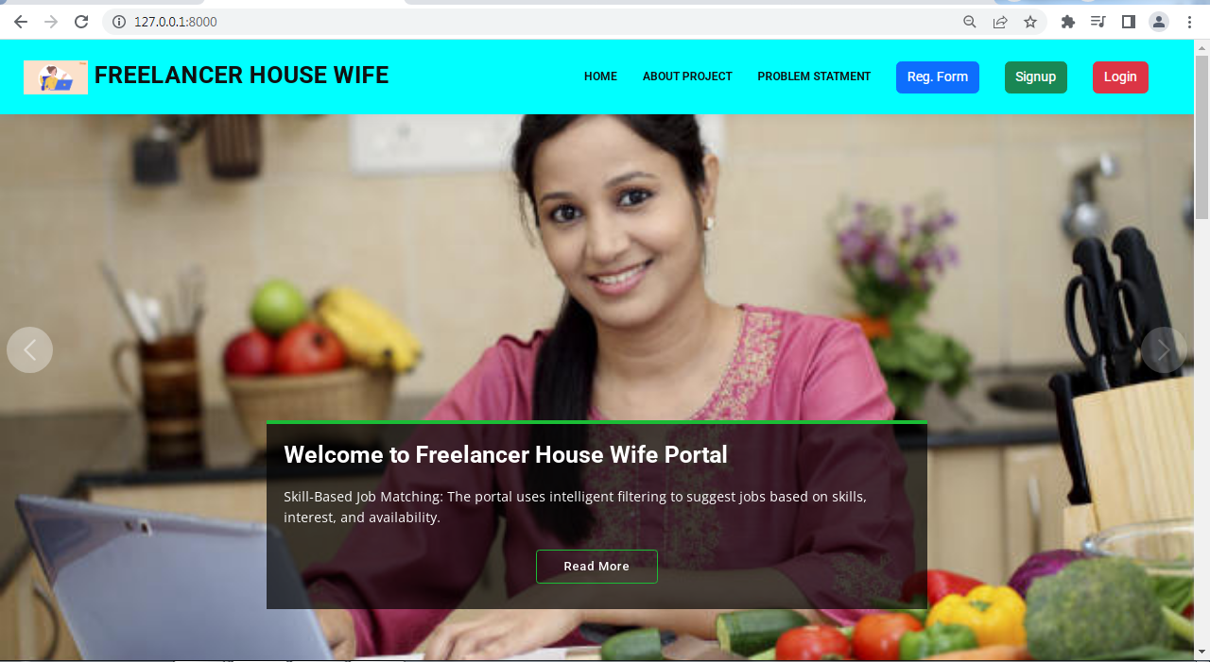

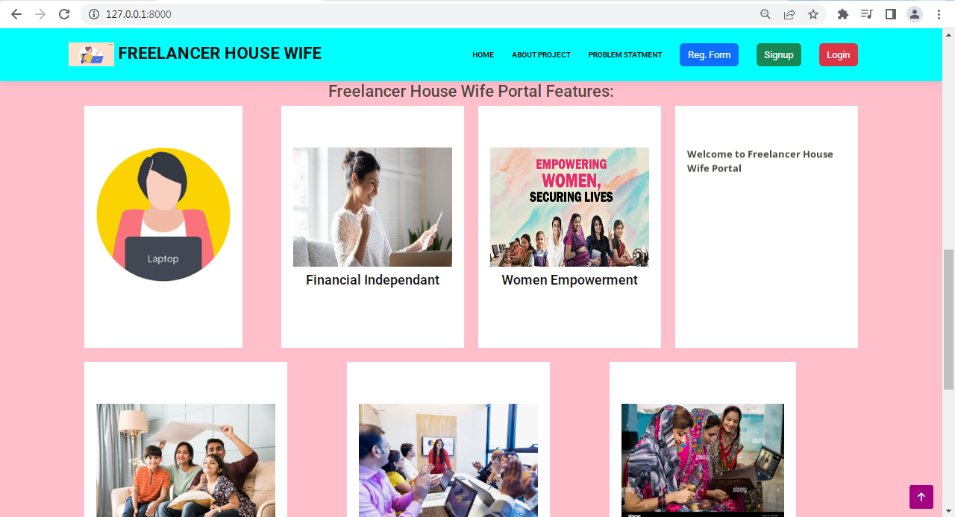

* **About Project Page:**

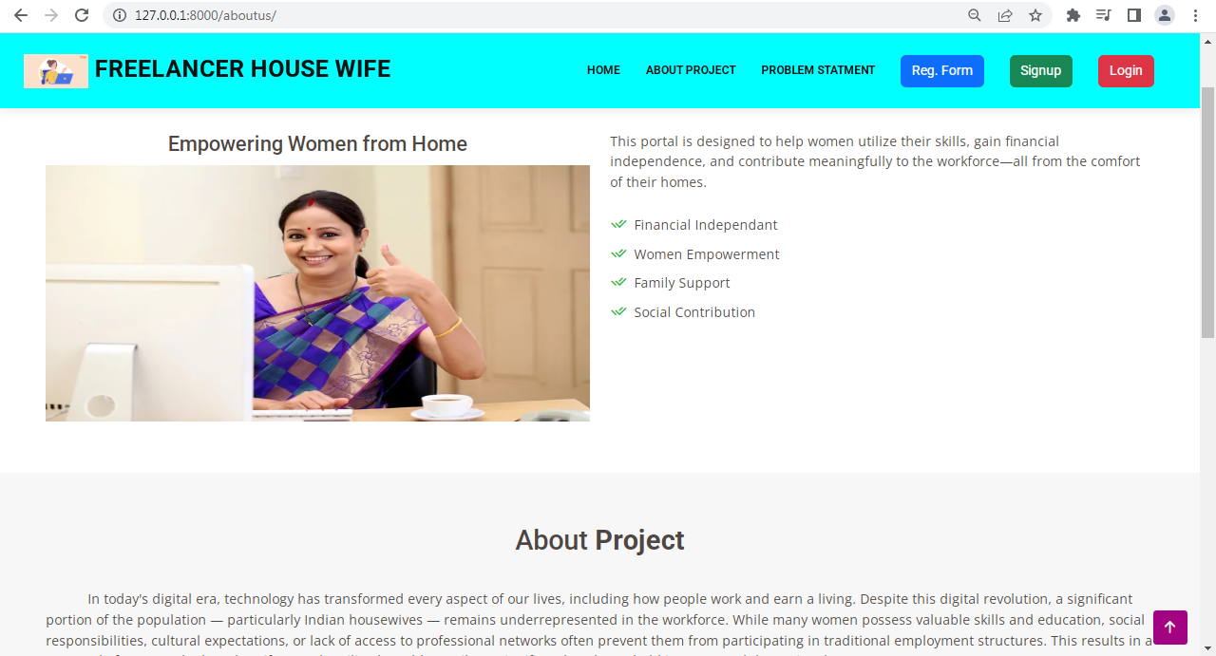

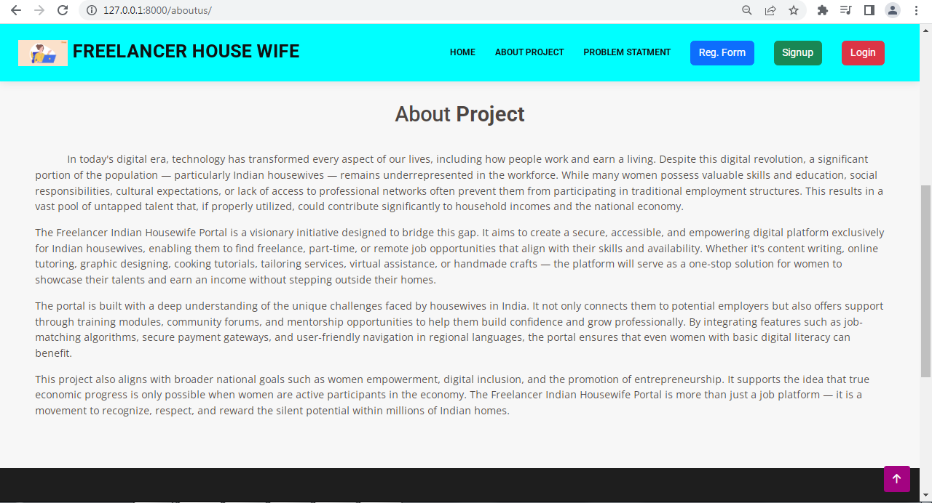

* **Project Statement Page:**

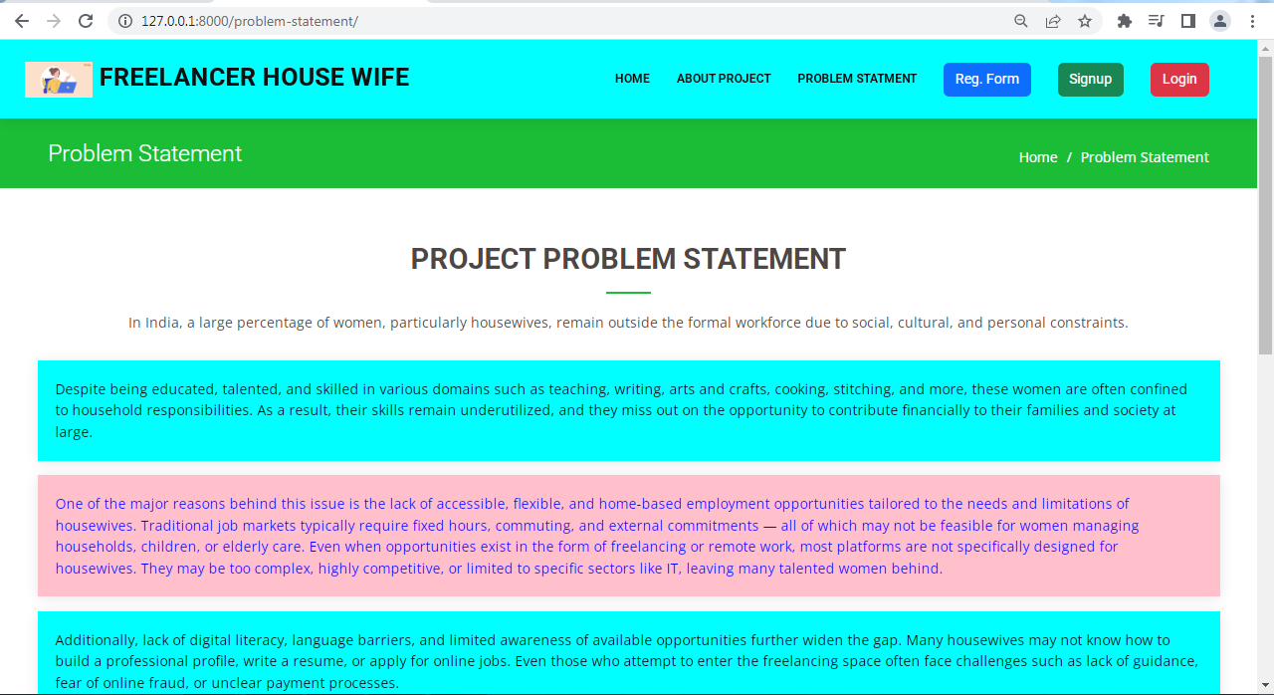

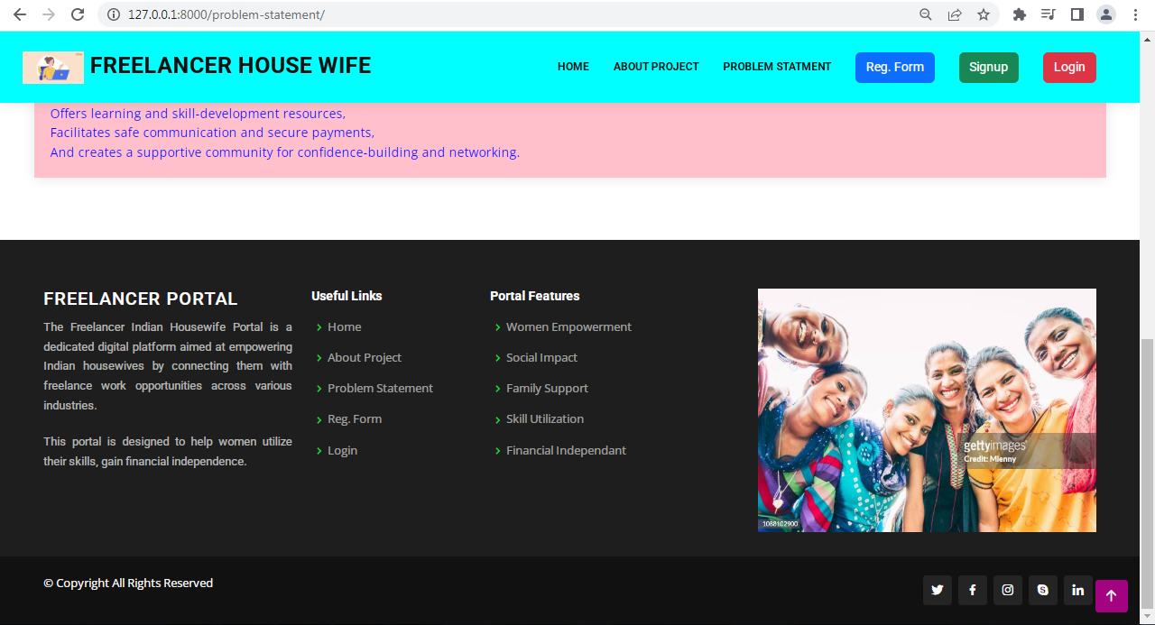

* **Project Registration Form:**

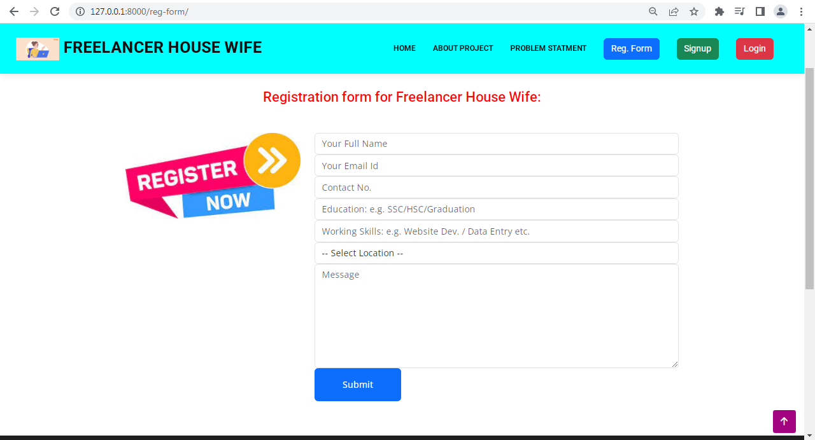

* **Project Sign-Up Form:**

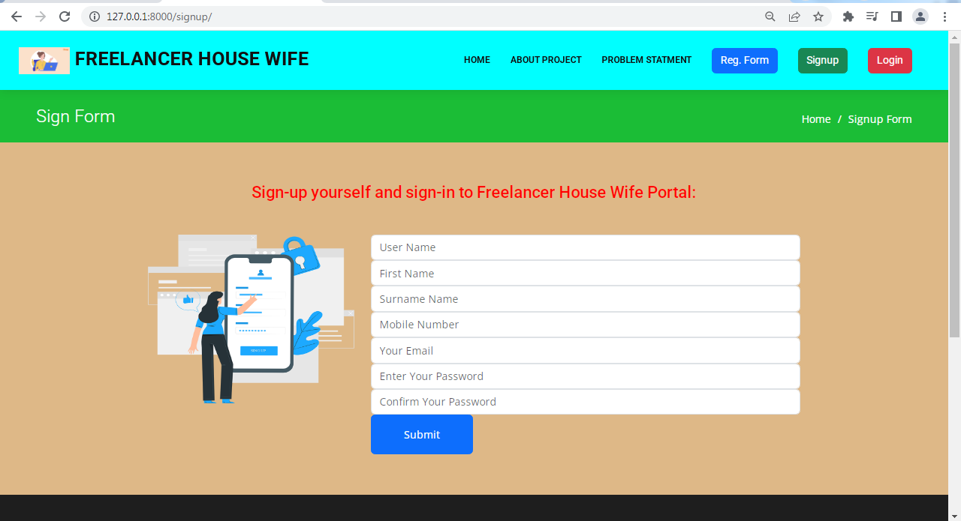

* **Admin Login Page:**

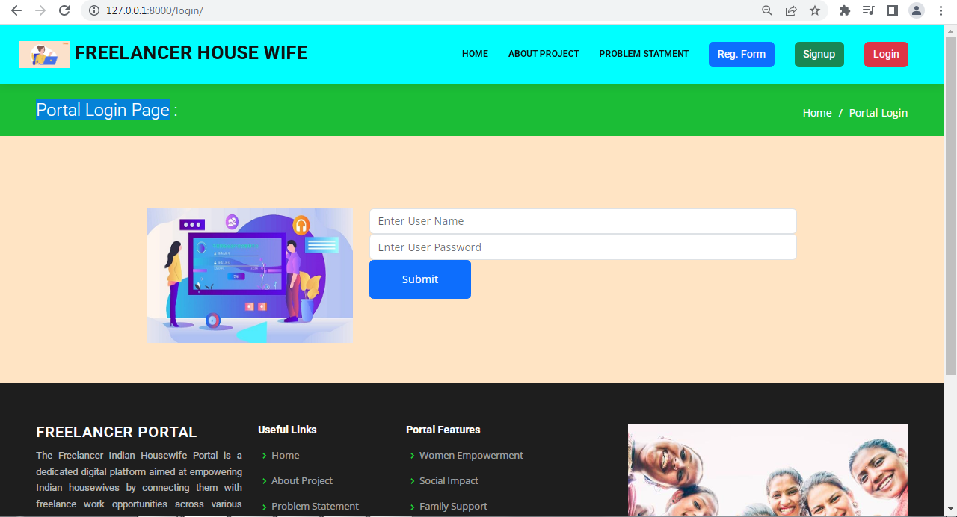

* **Login authorization:**

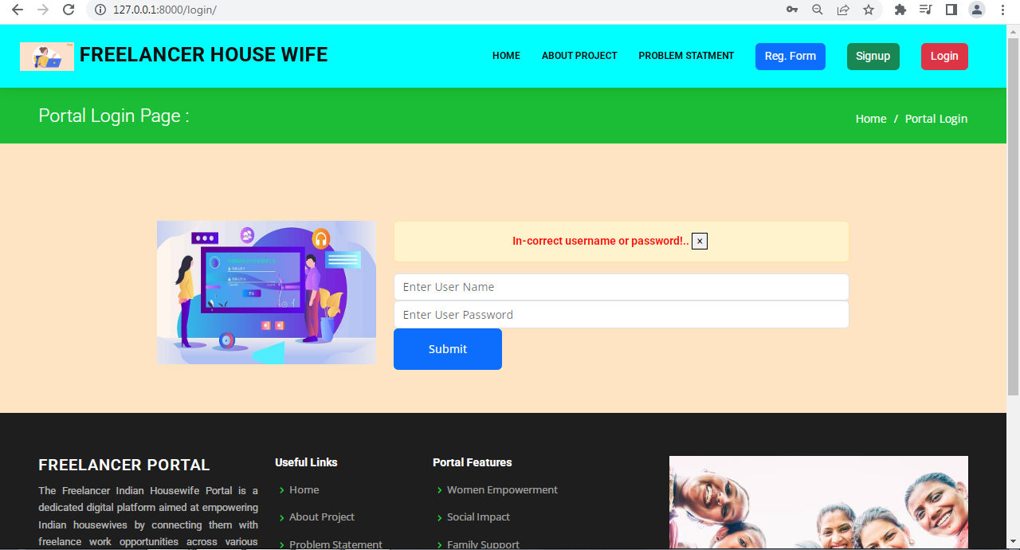

**Admin Back-End Screen Shots:**

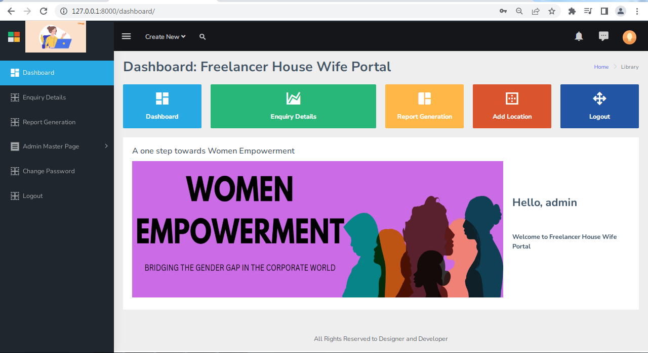

* **Admin – Reg. Records Fetching:**

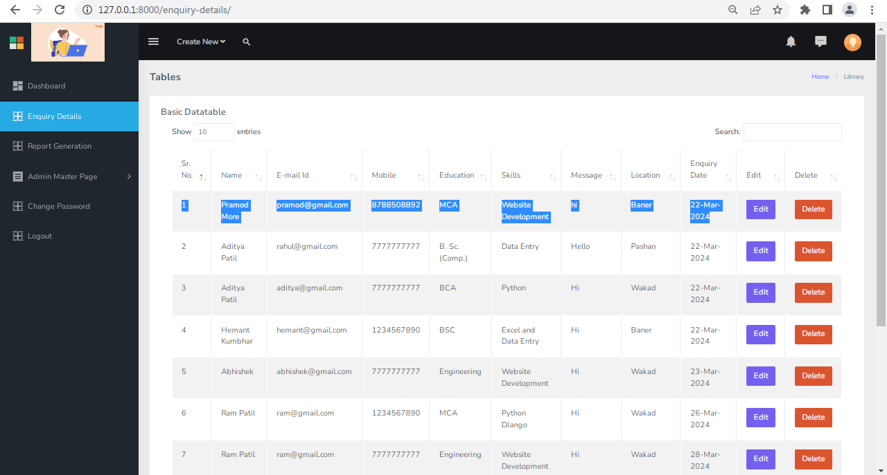

**Admin – Tables Record Edit Page:**

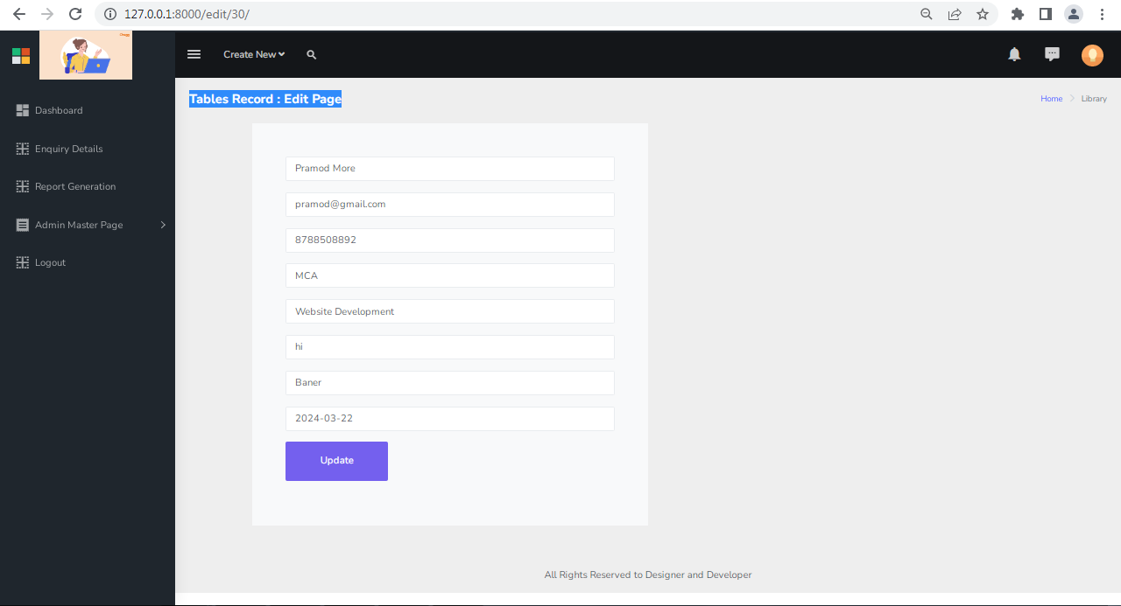

**Admin – Delete Operation:**

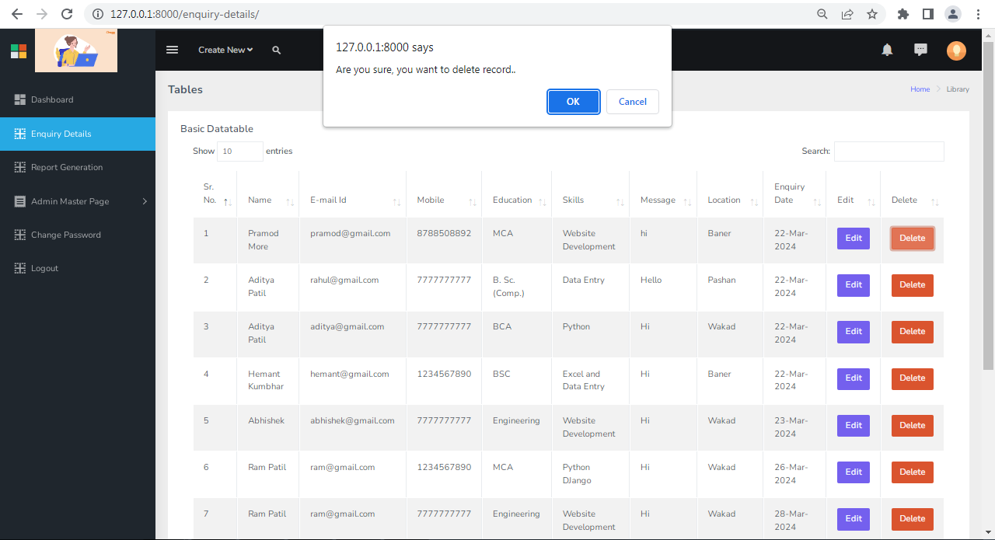

**Admin – Date wise Report Generation:**

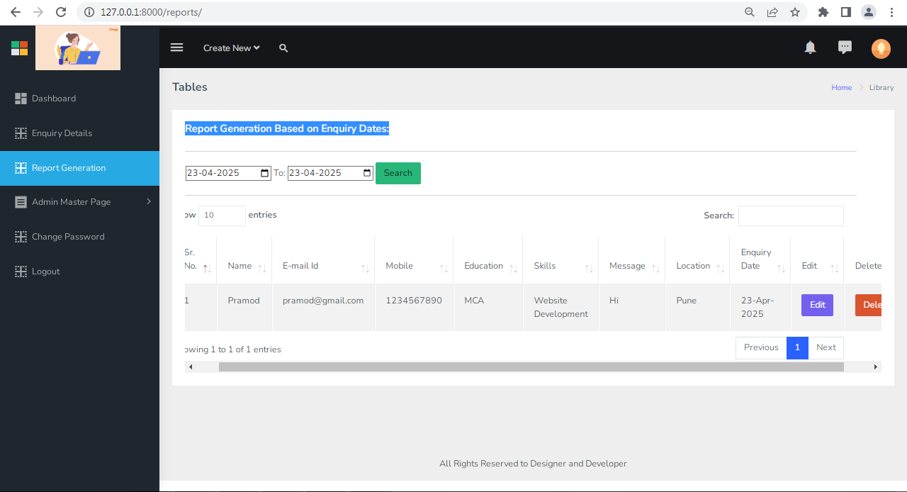

**Admin – Change Password Page:**

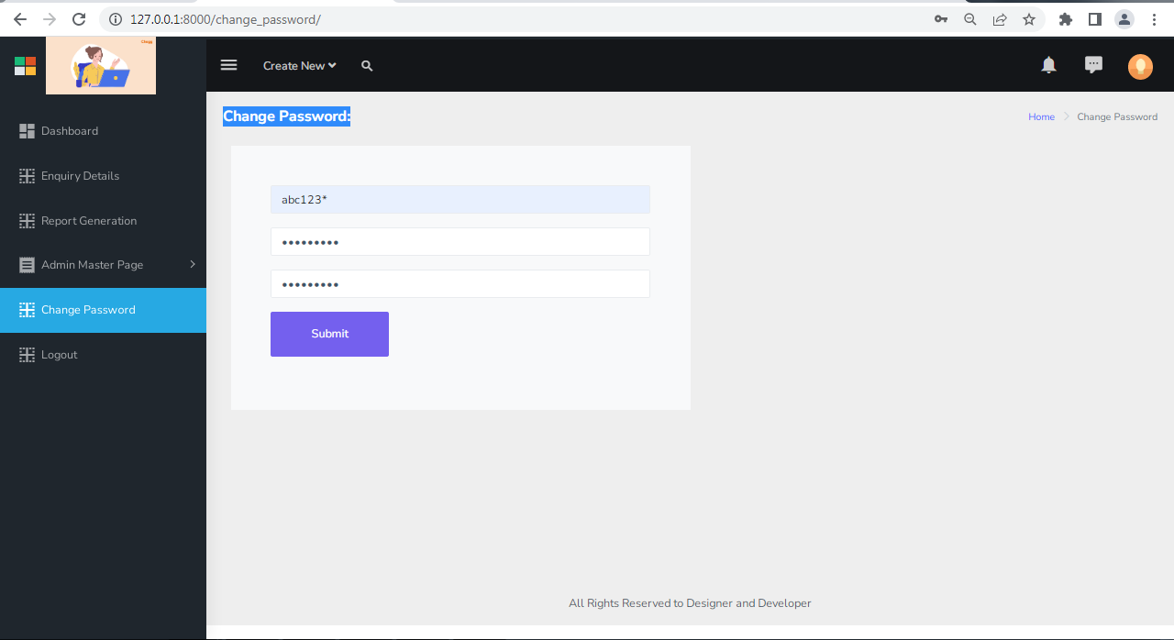

**Admin – Handling Anonymous Users:**

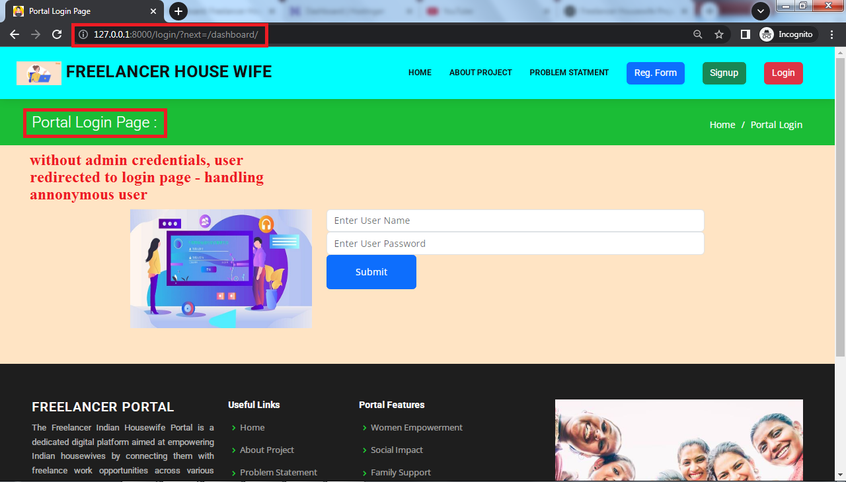

**Company – Work Assignment Form:**

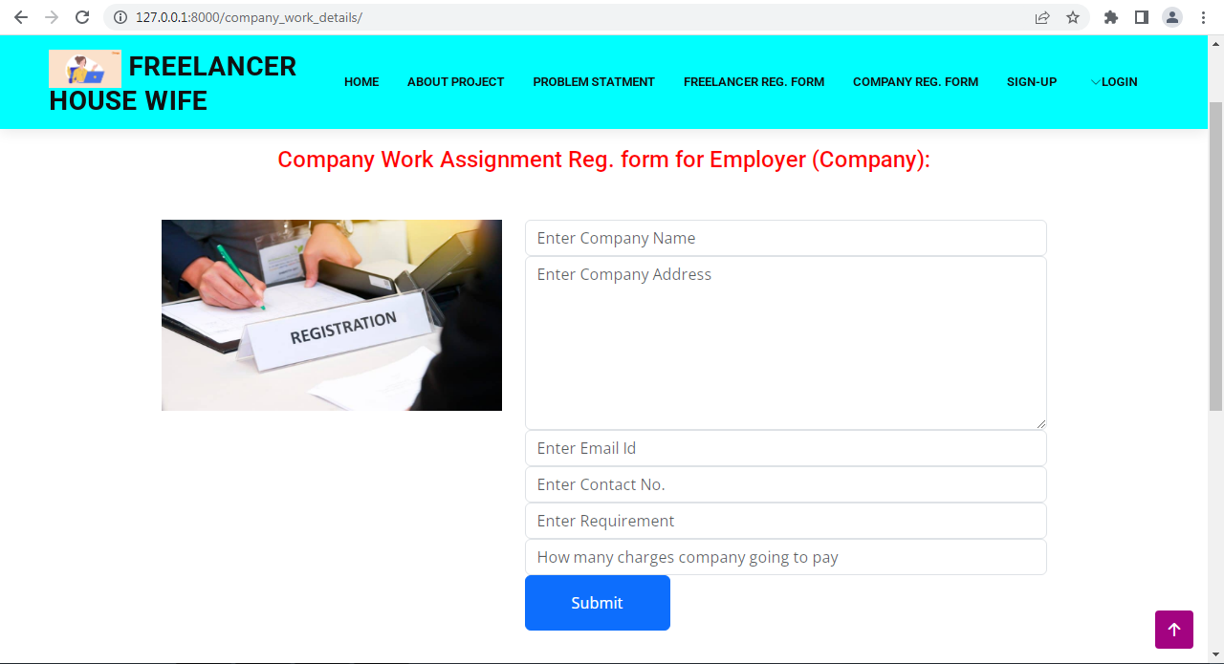

**Freelancer – Login Page:**

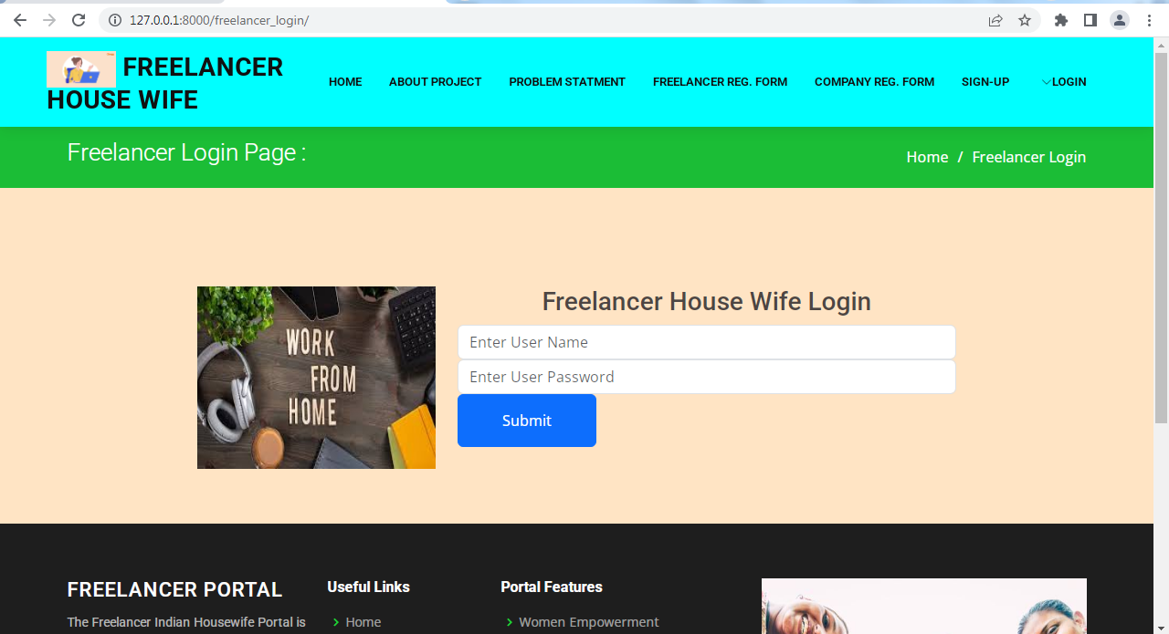

**Freelancer – Dashboard Page:**

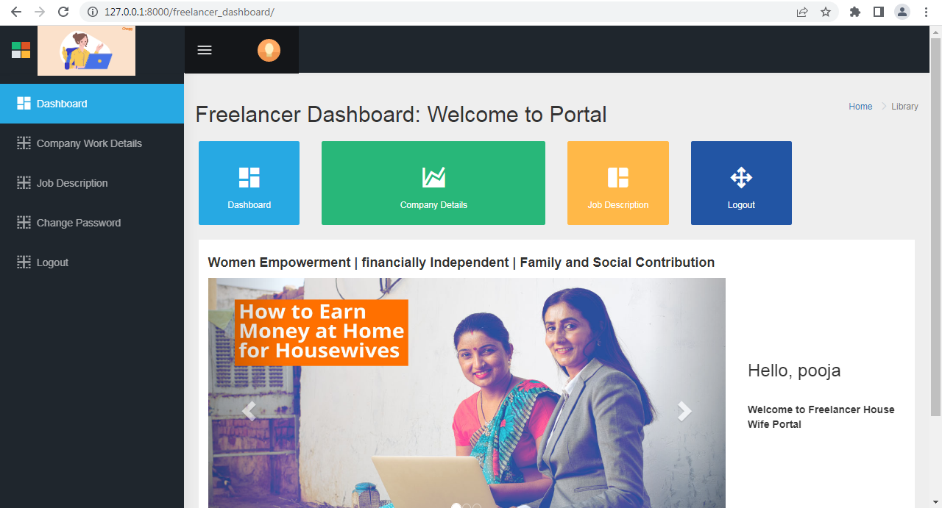

**Company – Work Details Page:**

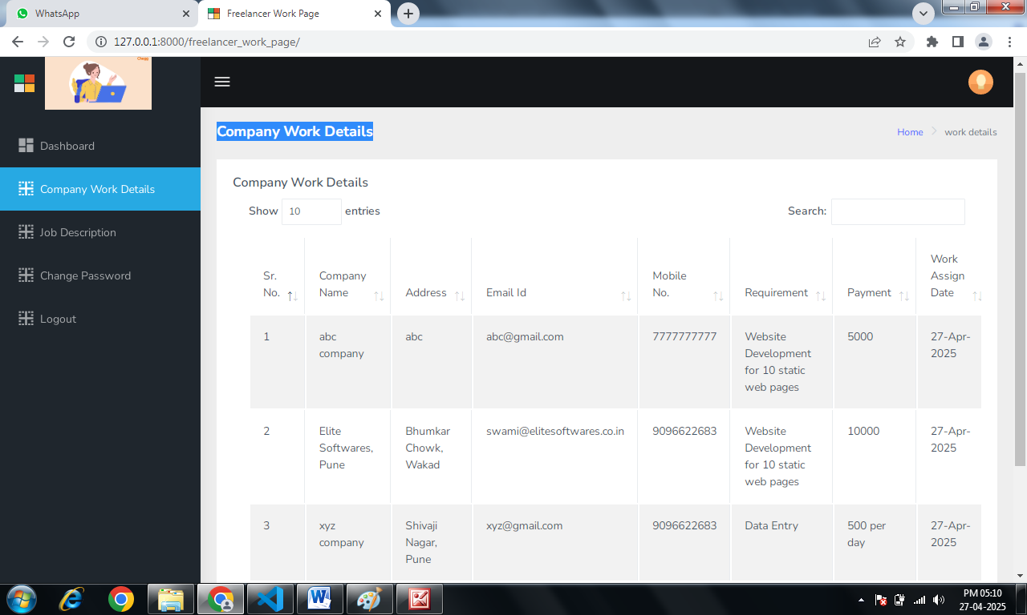

**Back-end Python Programming Coding Screens:**

# ***Identifier*** :

# A Python identifier is a name used to identify a variable, function, class, module or other object.

name = "Hello"

A=10

b=5.5

print(name)

print(A)

print(b)

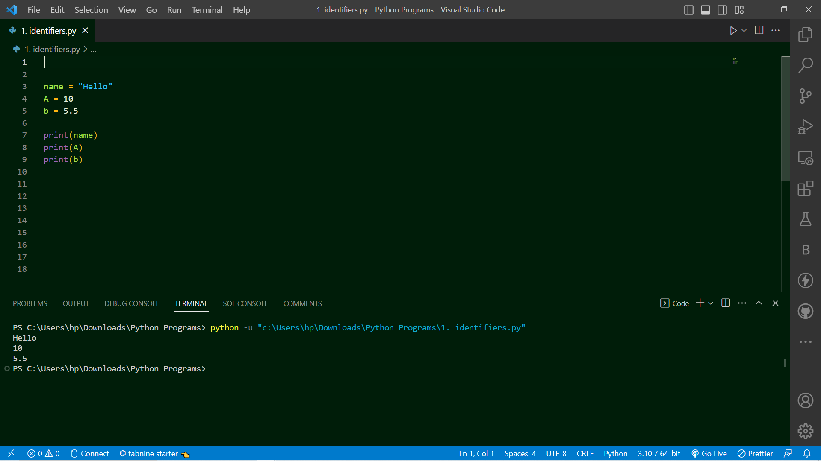

* **Topic Cover:-** Variable and Data Type’s , Type casting and operator.
* **Summary:**

**##Variable and data type’s**

# Four types of literals:

# 1) String literals,

# 2) Numeric literals,

# 3) Boolean literals and

# 4) a special literal None.

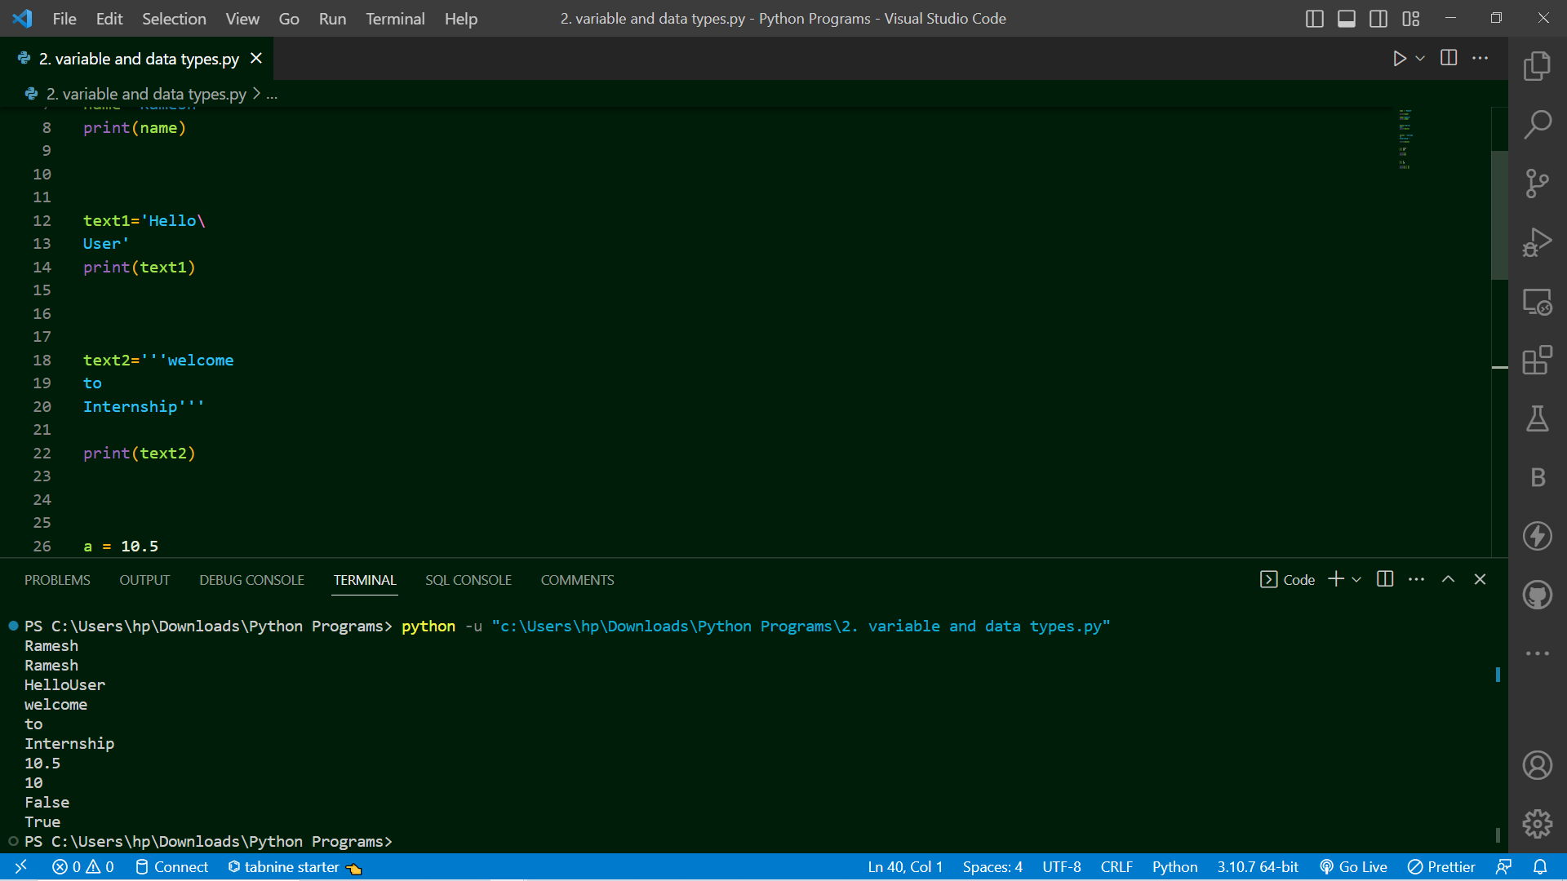

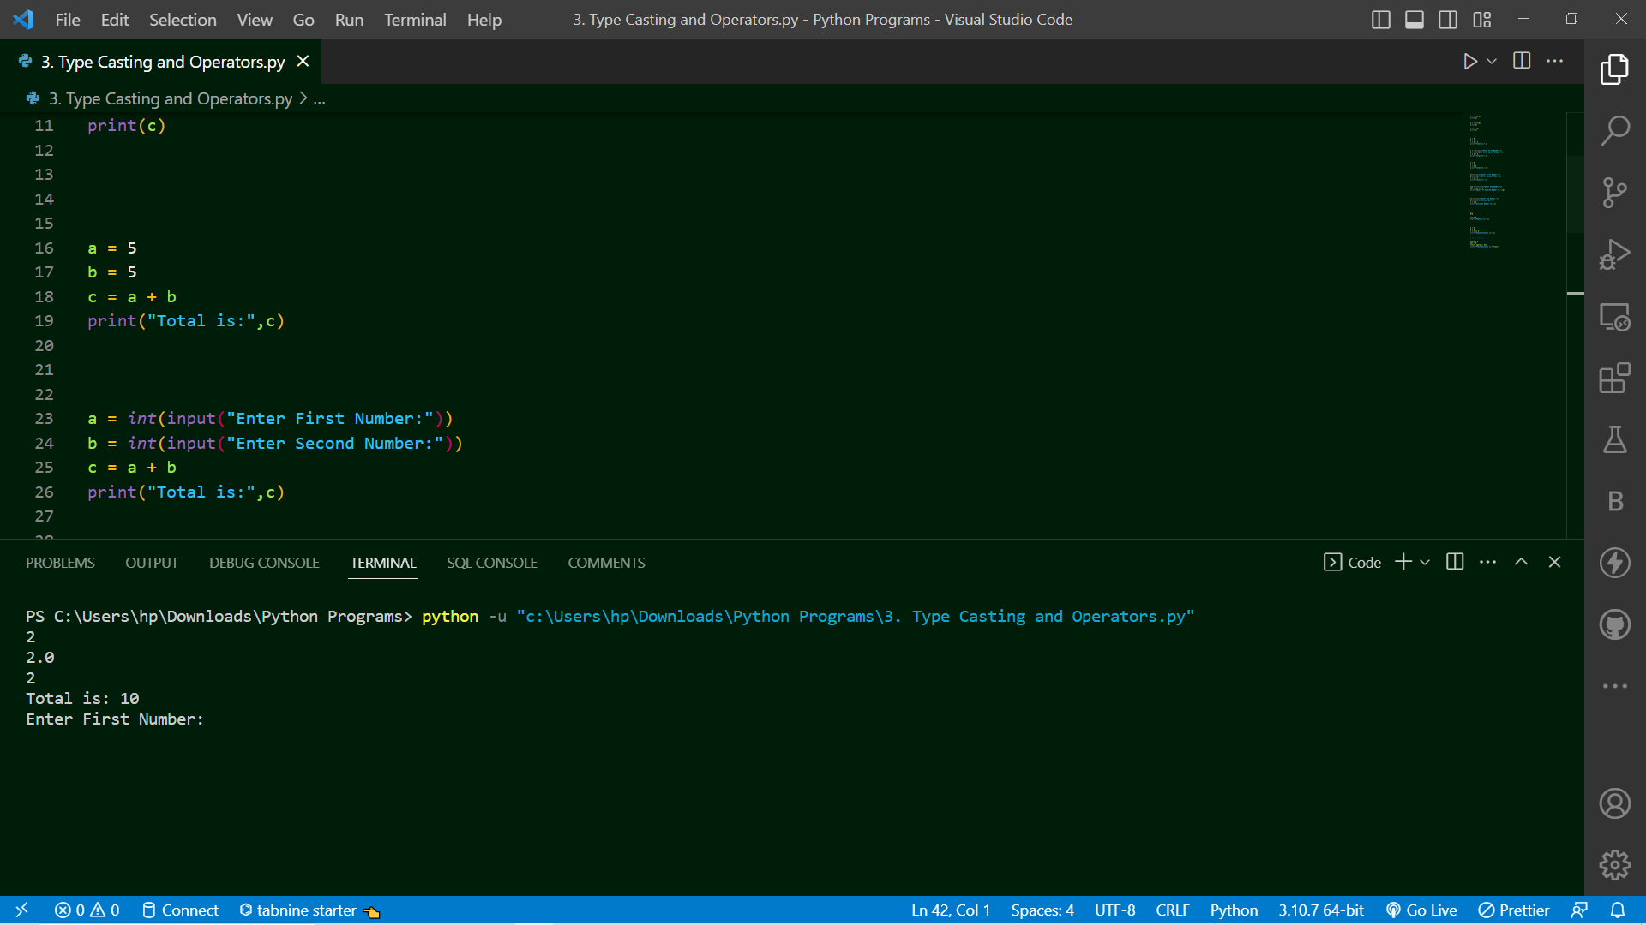

* **Topic Cover:-** String and string’s method.
* Summary:

# Strings in python are surrounded by either single quotation marks, or double quotation marks.

# Python Slicing Strings:

# You can return a range of characters by using the slice syntax.

# Specify the start index and the end index, separated by a colon, to return a part of the string.

# String Methods:

1. len()
2. lower()
3. upper()
4. replace("replacing word","new word which you want replace")
5. split()

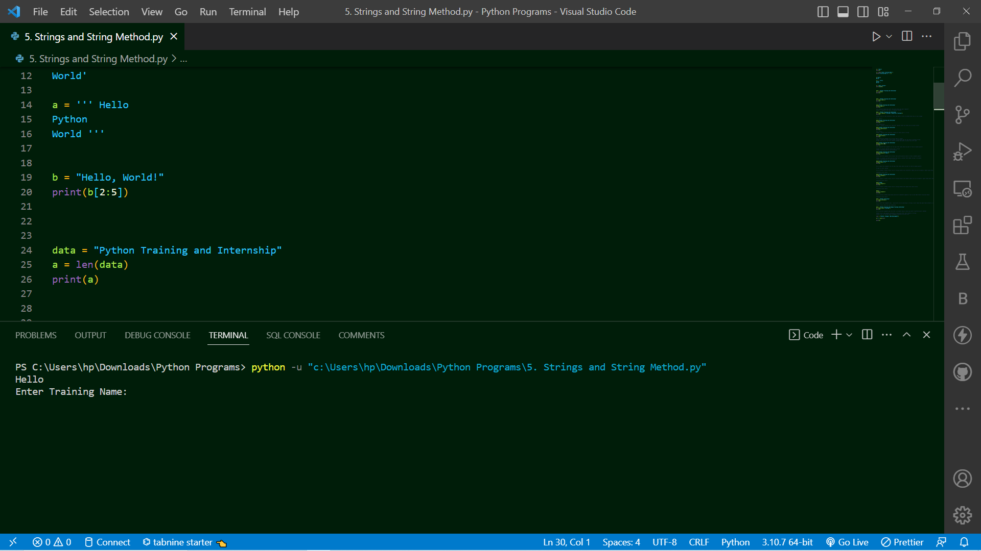

* **Topic Cover:-** List in python.
* Summary:

# Python Collections : 4 Types of Collections as:

# 1) List

# 2) Tuple

# 3) Set

# 4) Dictionaries

1) List:

# Lists are used to store multiple datatypes items in a single variable.

# List items are ordered, changeable (Mutuable), and allow duplicate values.

# Lists are created using square brackets

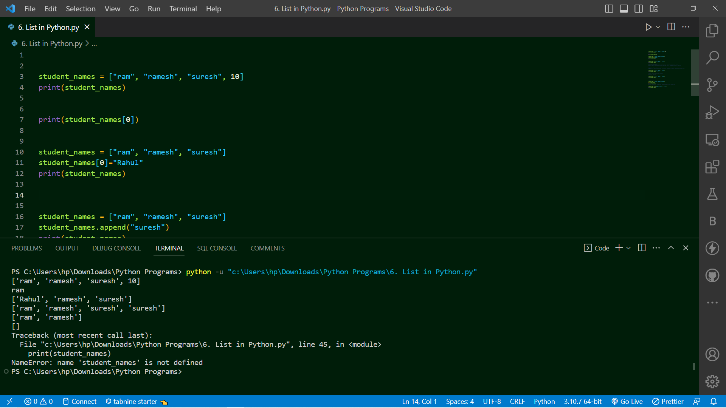

* **Topic Cover:-** Tuple in python.
* **Summary**:

# 2) Tuple:

# Tuples are used to store multiple datatypes items in a single variable.

# tuple items are ordered, immutable (un-changeable), and allow duplicate values.

# tuple are created using round brackets (or also called paranthesis)

student_names = ("ram", "ramesh", "suresh")

print(student_names)

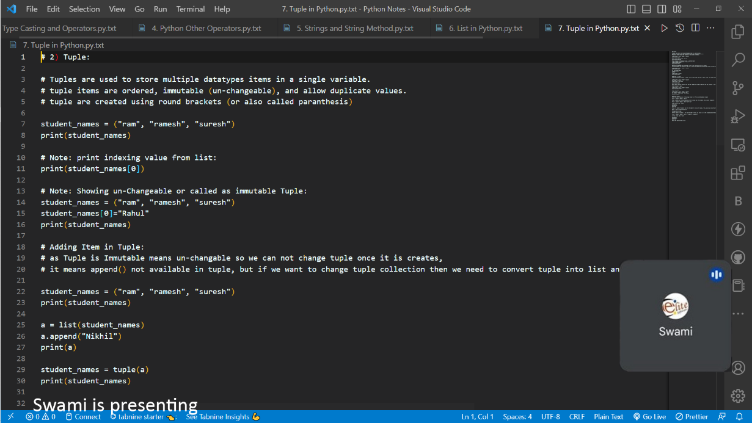

* **Topic Cover:-** Sets in python.
* **Summary:**

# 3) Set:

# Set is a collection which is un-ordered,

# Set is un-changeble, un-indexed and do not allow duplicate value

# set are created using curly braces { }

# Un-ordered Set collection

student_names = {"ram", "ramesh", "suresh"}

print(student_names)

# Un-changeble - Immutable Set collection

student_names = {"ram", "ramesh", "suresh"}

student_names[0]="rahul"

print(student_names)

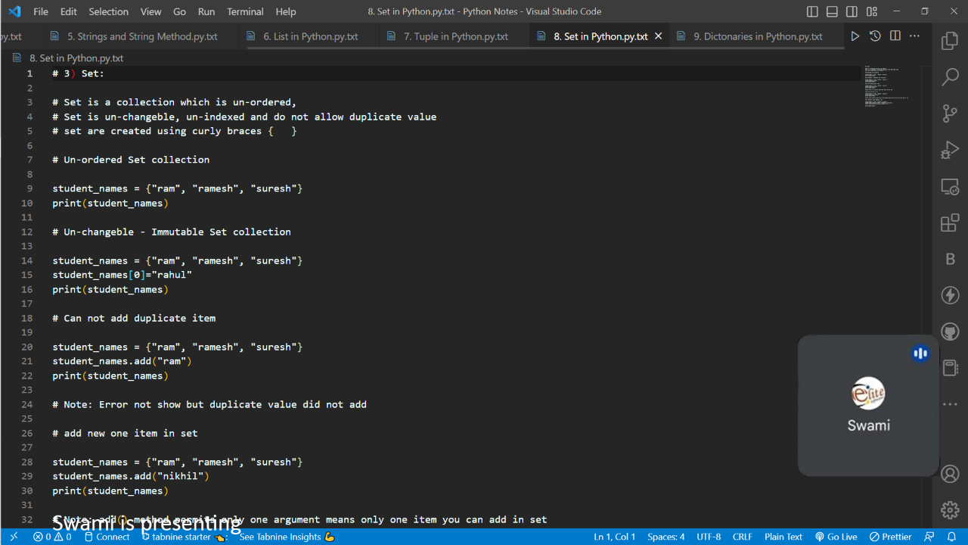

* **Topic Cover:-** Dictonary in python.
* **Summary:**

# 4) Dictonaries:

# Dictionary is a collection which is ordered,

# dictionary items are changeable and do not allow duplicates.

# dictionary are created using curly braces { }

# Dictionaries are used to store data values in key:value pairs "" : ""

# Note : As of Python version 3.7, dictionaries are ordered. In Python 3.6 and earlier, dictionaries are un-ordered.

# Create and print a dictionary:

mobile = {

"brand":"apple",

"model":"iphone12",

"Year":"2022",

}

print(mobile)

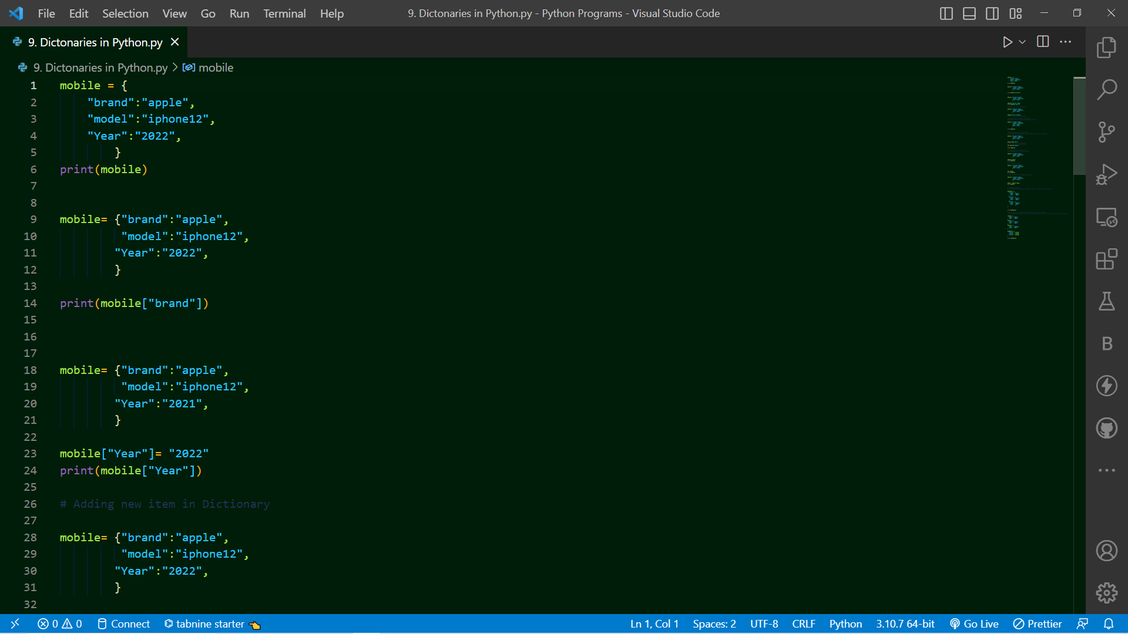

* **Topic Cover:-** Python condition and if statement
* **Summary:**

# Python supports the usual logical conditions from mathematics:

# Equals: a == b

# Not Equals: a != b

# Less than: a < b

# Less than or equal to: a <= b

# Greater than: a > b

# Greater than or equal to: a >= b

# These conditions can be used in several ways, most commonly in "if statements" and loops.

# "if statement" is written by using the if keyword.

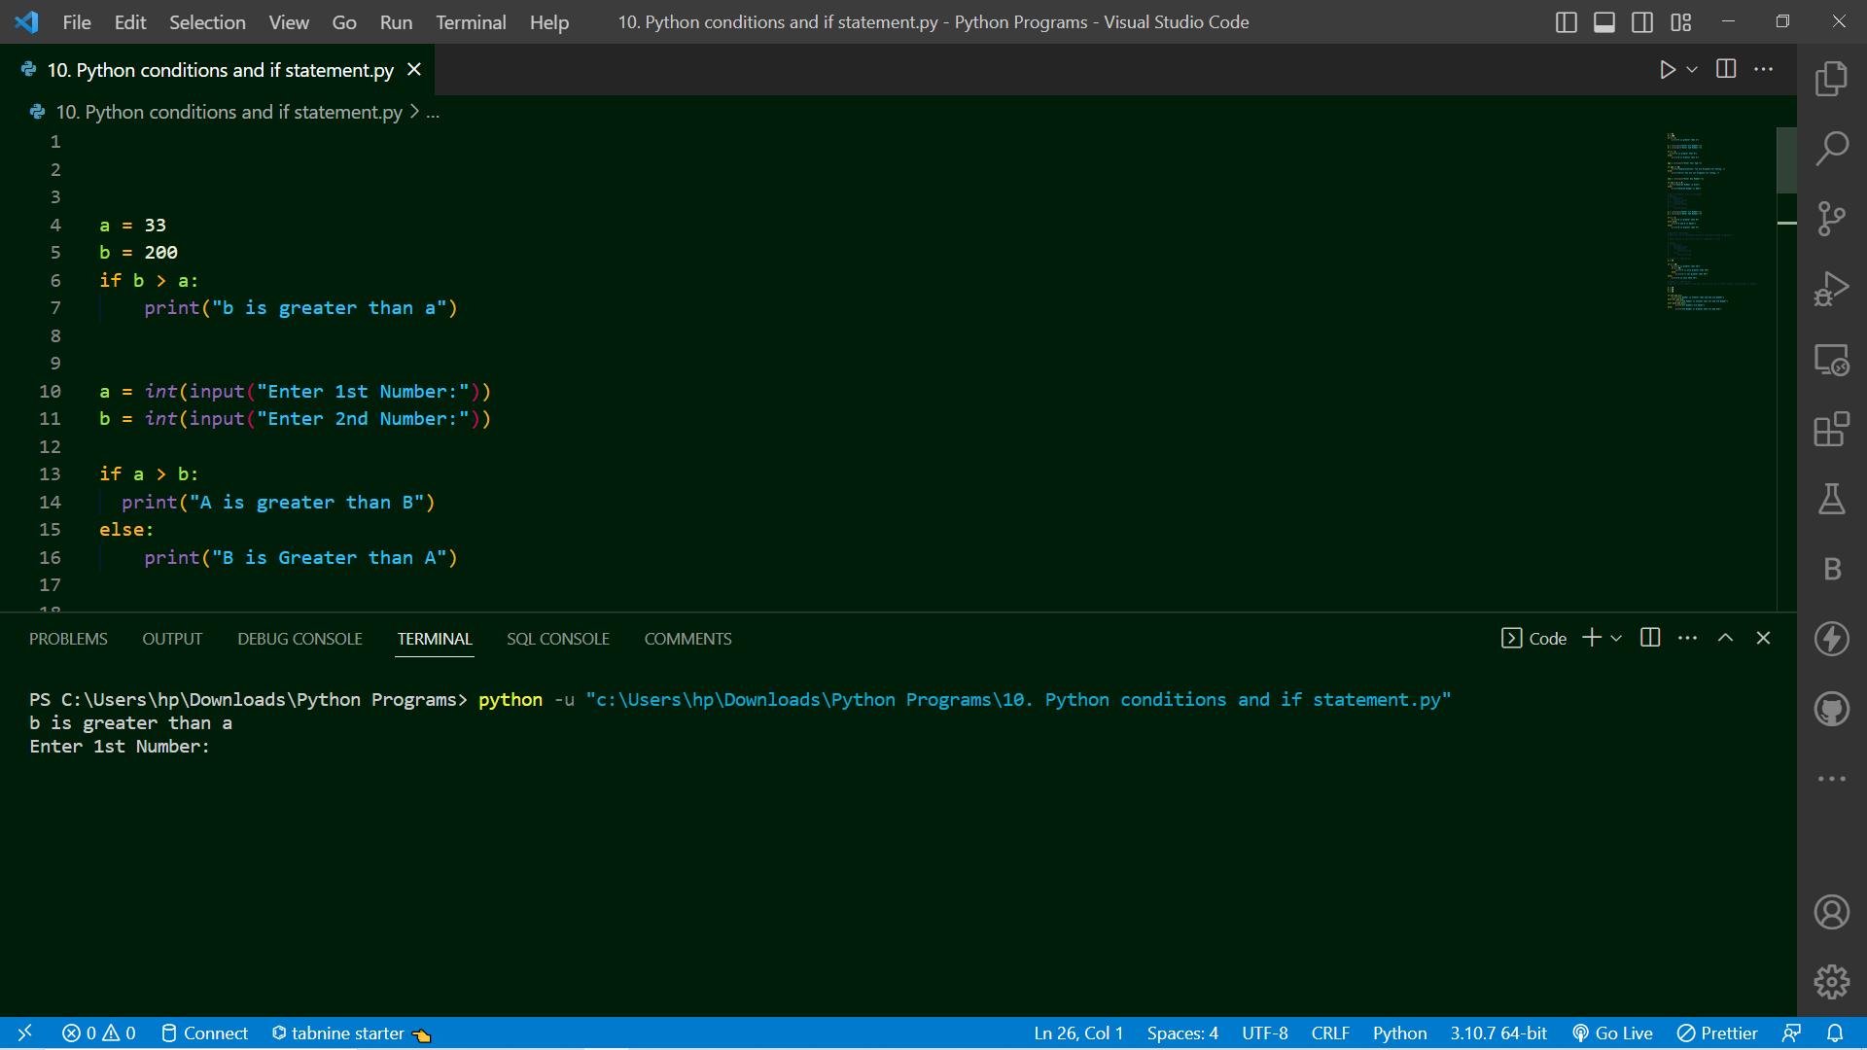

* **Topic Cover:-** Loops in python and function in python
* **Summary:**

**1)**

# Looping Statement : While Loop and For Loop

# excecute block of statements till condition is false

# While Loop

a = 1

while a <= 10:

print(a)

a += 1

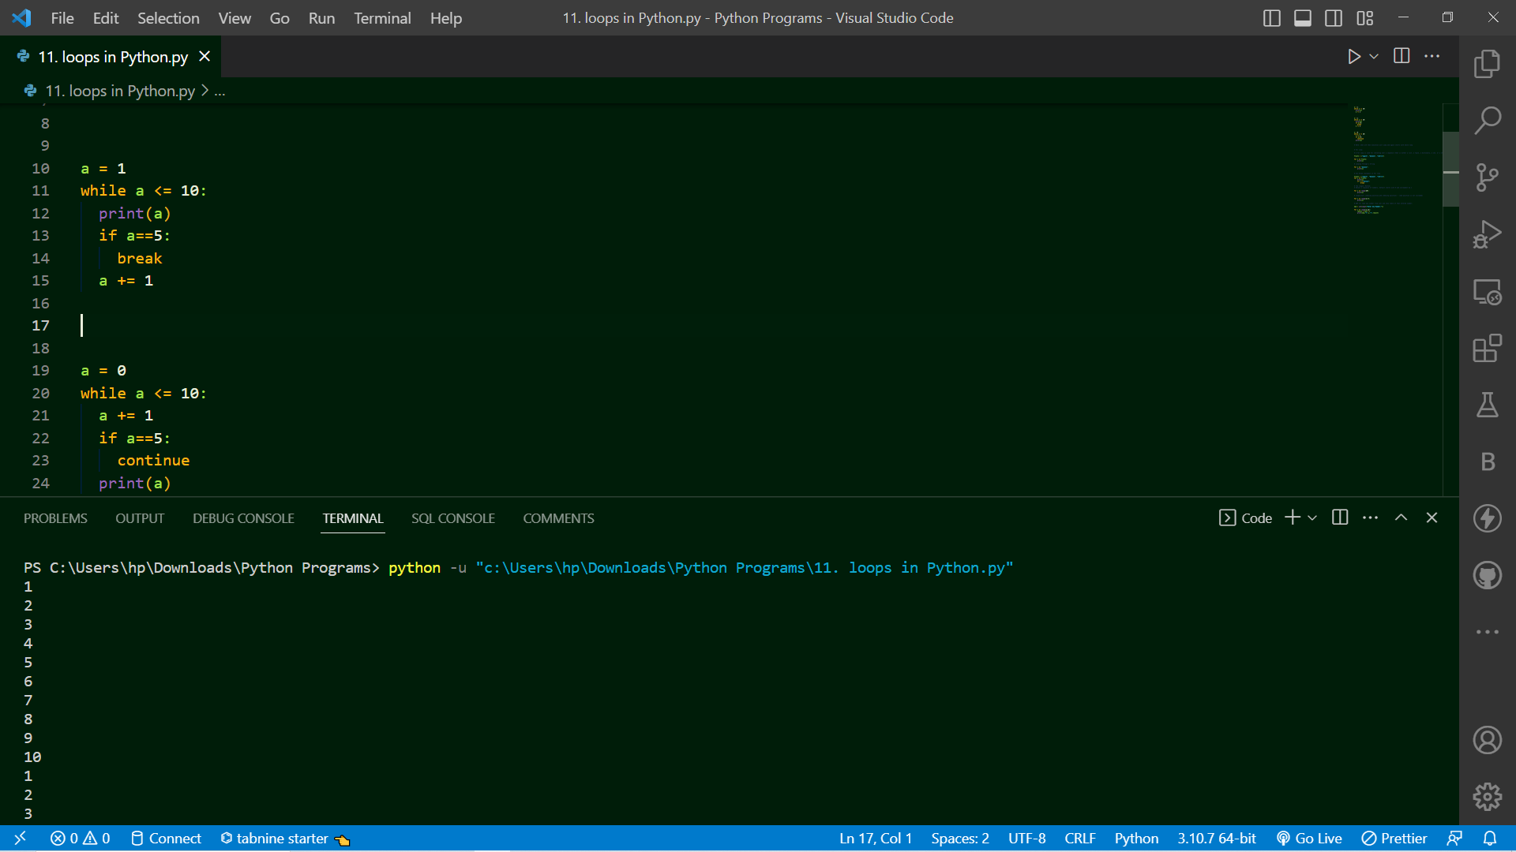

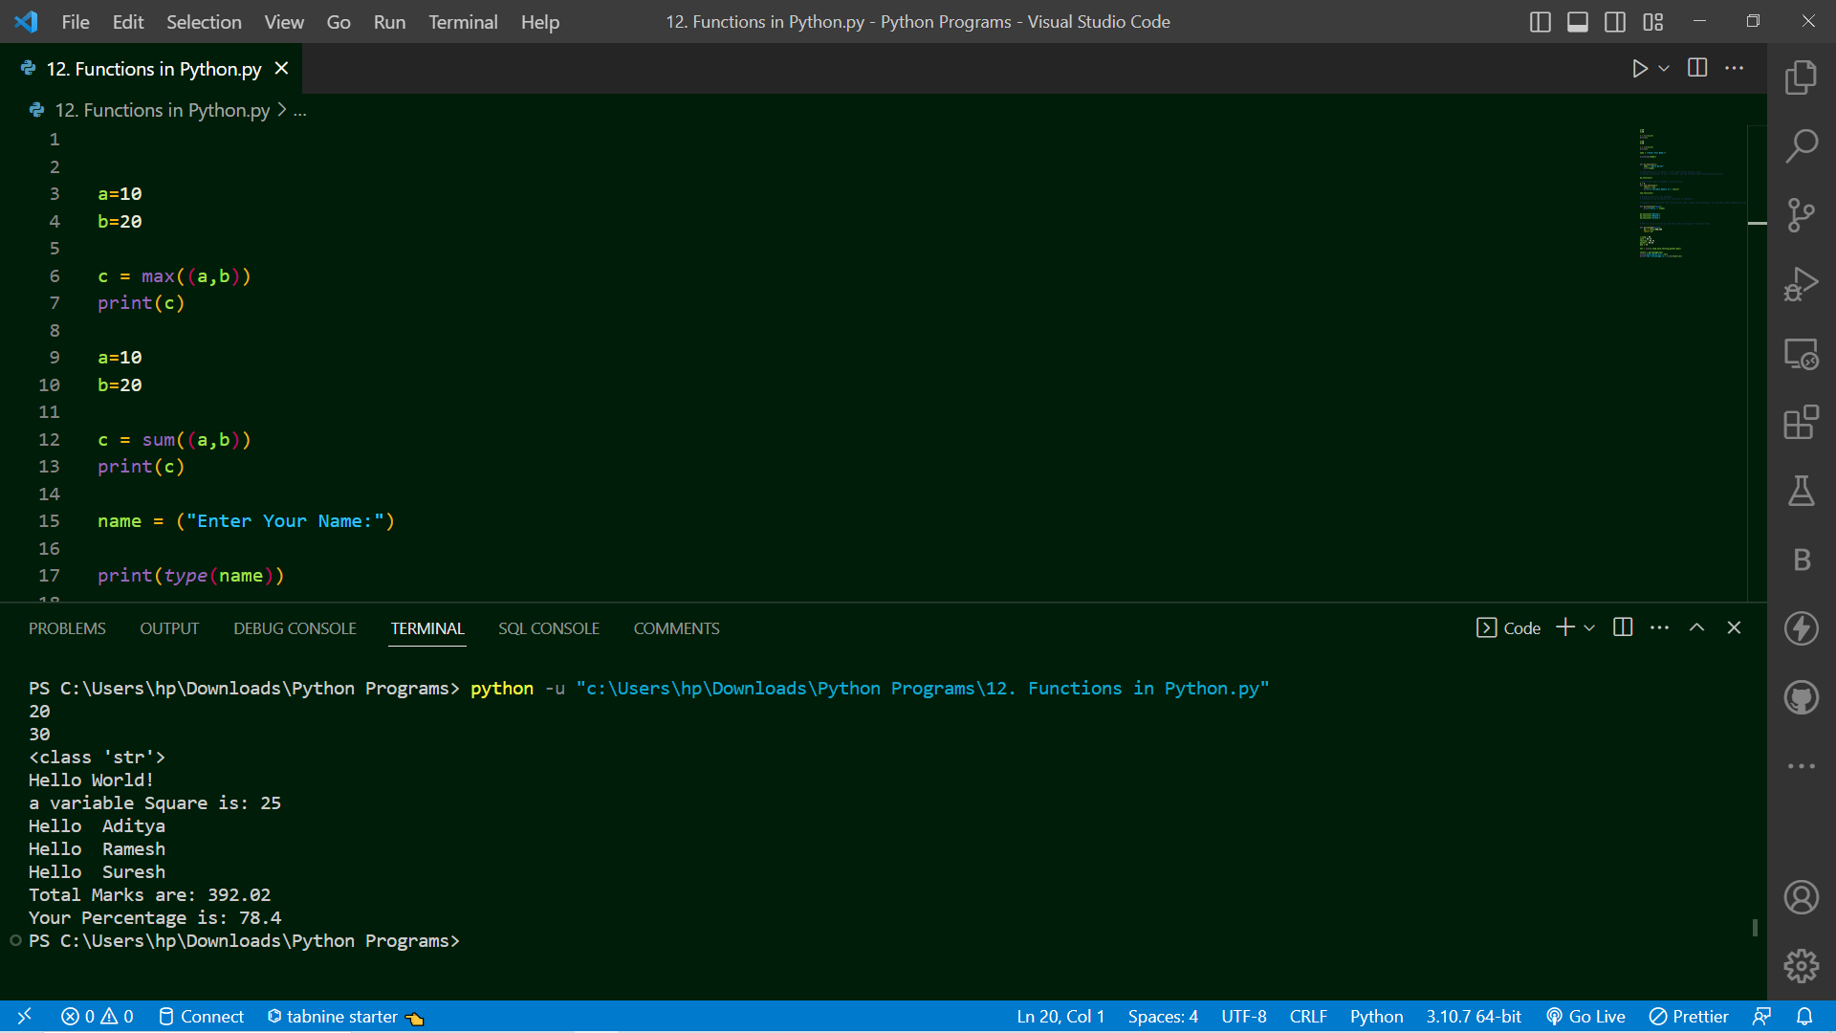

* **Topic Cover:-** Lambda function in python and python module
* **Summary:**

**1)**

# A lambda function is a small called as one line or anonymous function.

# A lambda function can take any number of arguments, but can only have one expression.

# Syntax : lambda arguments : expression

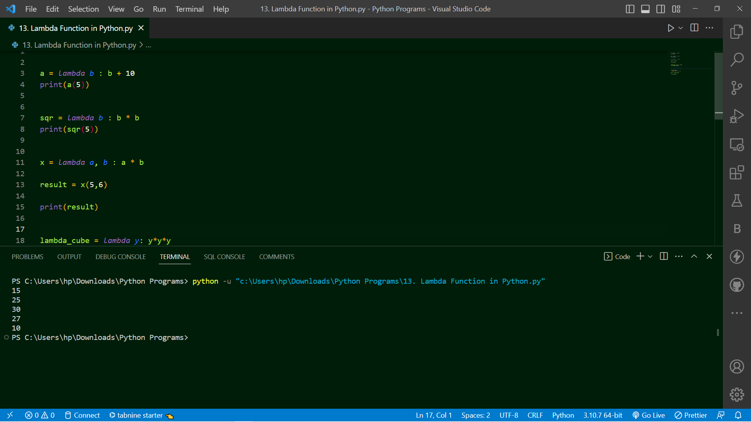

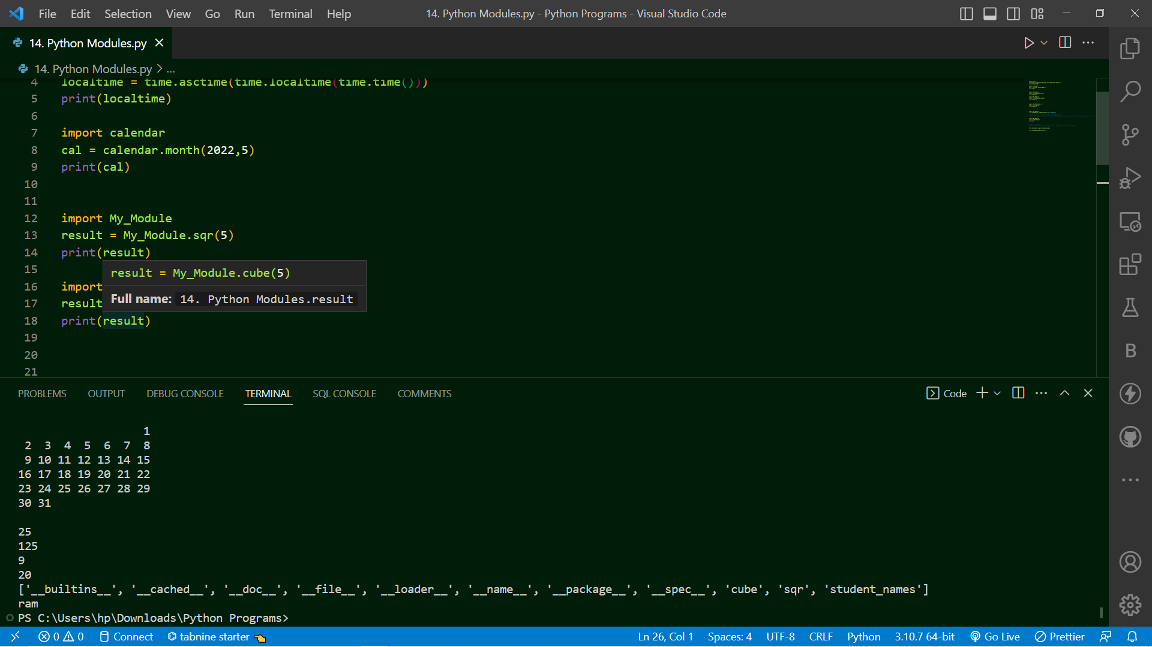

* **Topic Cover:-** File Handling and OOP’s Concept
* **Summary:**

# File Handling in Python:

# File handling is an very important part of any web application.

# Python has several functions for creating, reading, updating, and deleting files.

# Two Types of Files :

# 1) Text Files (Ex. .txt) represent as "t"

# 2) Binary Files (Ex. .jpg, .dat) represent as "b"

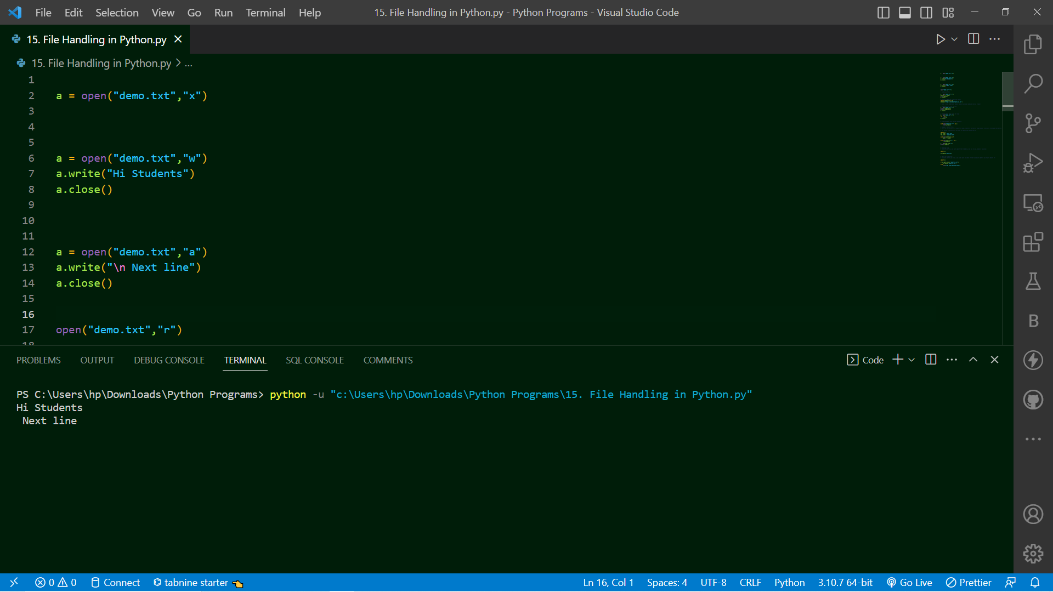

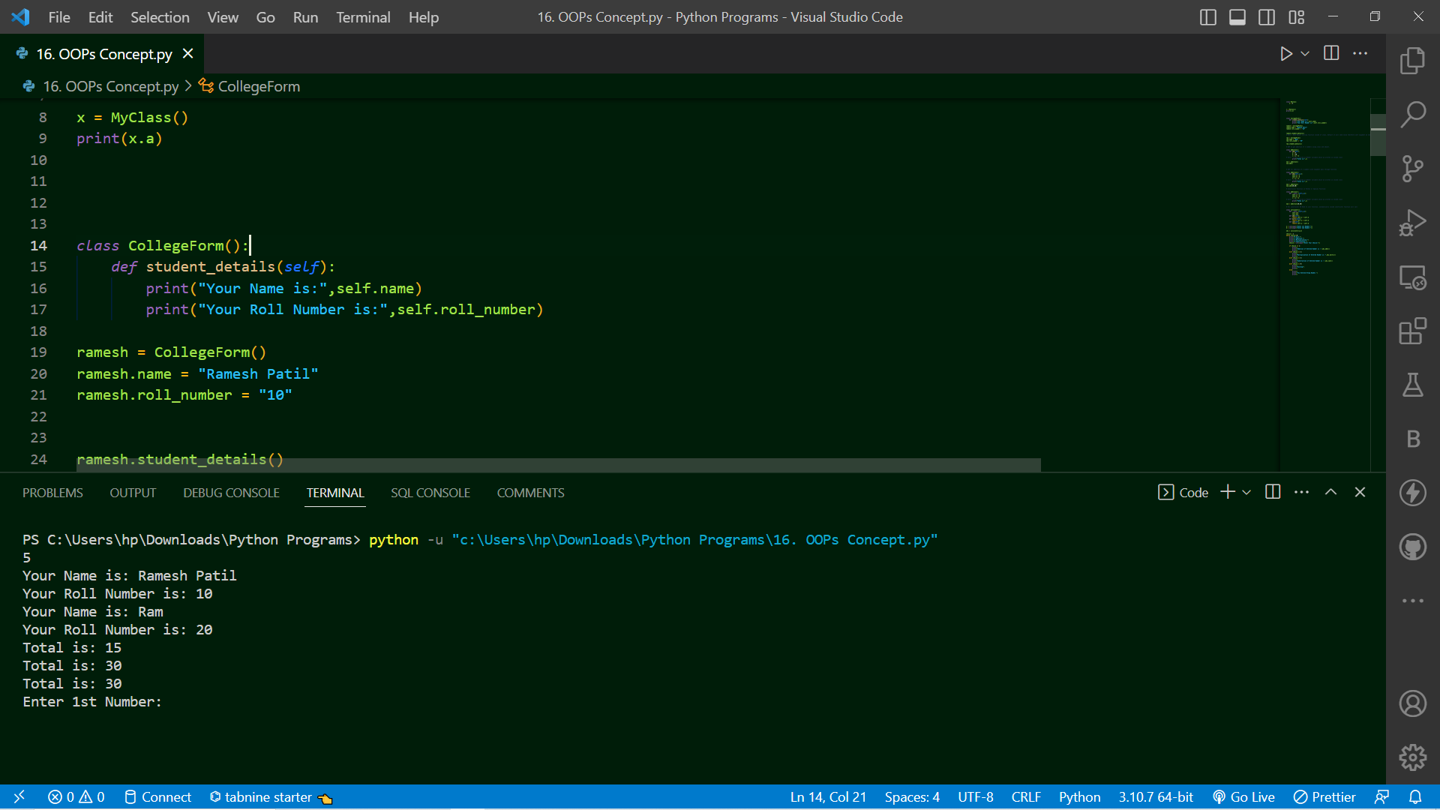

* **Topic Cover:-** SQLite database create using database and creating ,inserting data into table
* **Summary:**

**1)**

# Python SQLite3 module is used to integrate the SQLite database with Python.

# Using SQLite3 Module you can perform all possible DB operations like creating database, creating table and performing various operations on table.

Connecting SQLite Database through Python:

# As mention using SQLite3 module we can integrate SQLite Database therefore as we import any module similarly we can import sqlite3 module in our program and can connect sqlite database through python.

import sqlite3

# compulsory we need to import sqlite3 module for performing databse related operations.

con = sqlite3.connect("test.db")

# con is connection_object for database

**2)**

# Creating table using Python:

import sqlite3

con = sqlite3.connect("test.db")

cur = con.cursor()

# Cursor() is a class which having methods like execute(), fetchall(), fetchmany(), fetchone(), etc. and if we want to access cursor class methods therefore we need to create object of cursor class and then only we can call methods under cursor() class

cur is the object of cursor

**Back-end DJango Framework:**

* **Topic Cover:-** Getting started with Django and creating first project
* **Summary:**

**Py –m PIP install django**

# command we can install django framework

Creating project of name First_Project using terminal:

**django-admin startproject Project_name**

# if showing "django-admin" not recognized internal or external command - error

# then we need to run below command:

**python -m django startproject Project_name**

# Note : underscore _ is allowed in Project Name as Prject_ABC

# Note : Project Name does not allowed : spaces as Project College, - as Project-College, digits before name as 123Project not allowed

Project1

    # manage.py

    # Project1/

    #     __init__.py

    #     asgi.py

    #     settings.py

    #     urls.py

    #     wsgi.py

# These are default files and folder which created by django framework

# Run the Django Project on Browser before that you need to enter in that project Name using:

# On Terminal type :

cd Project_Name

# and then you can run project

# On Terminal type :

python manage.py runserver

or

py manage.py runserver

or

python3 manage.py runserver

# Python excute and start server and gives you ip address to see output

# Python excute and start server and gives you ip address to see output

# System check identified no issues (0 silenced).

# ←[31m

# You have 18 unapplied migration(s). Your project may not work properly until you apply the migrations for app(s): admin, auth, contenttypes, sessions.←[0m

# ←[31mRun 'python manage.py migrate' to apply them.←[0m

# Django version 3.2.13, using settings 'Project_Name.settings'

# Starting development server at

  http://127.0.0.1:8000/

# Quit (stop) the server with CTRL-C

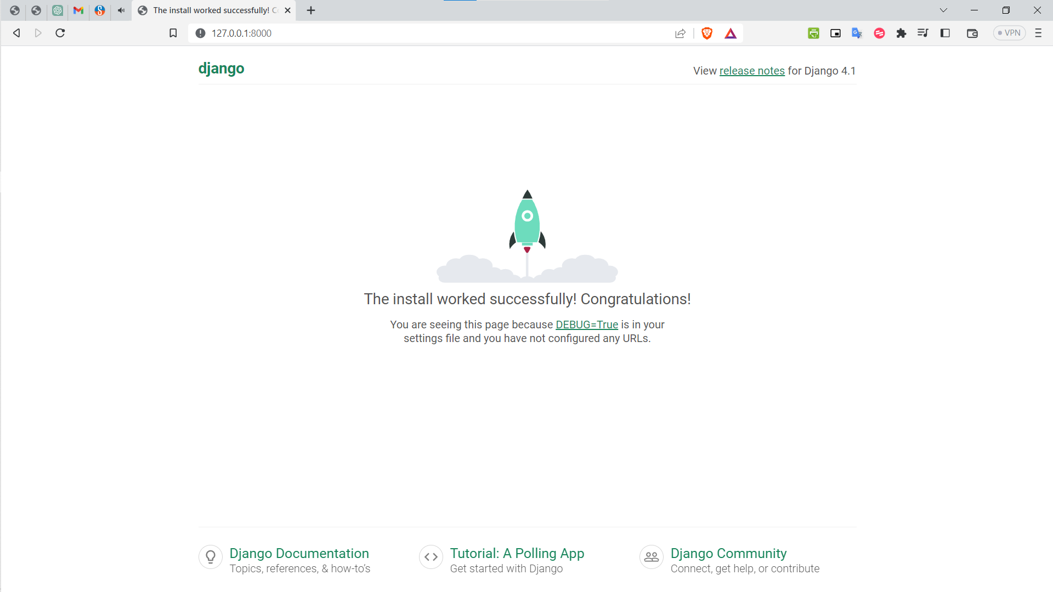

* **Topic Cover:-** 3. Create App and urls dispatcher
* **Summary:**

What is an App?

# An app is Web Application use to create different task like website app for complete Website as Home Page, About Us Page, Contact Us Page, etc, a contact form, or website blog, or any other application which you want to run seperately.

# Minimum 1 app you need to create to run web application

# Create App (Module) in your Project:

# Will give name to app as application

# In the Terminal type:

**py manage.py startapp application**

**DJango Framework: URLS.py file:**

**DJango Framework: VIEWS.py file:**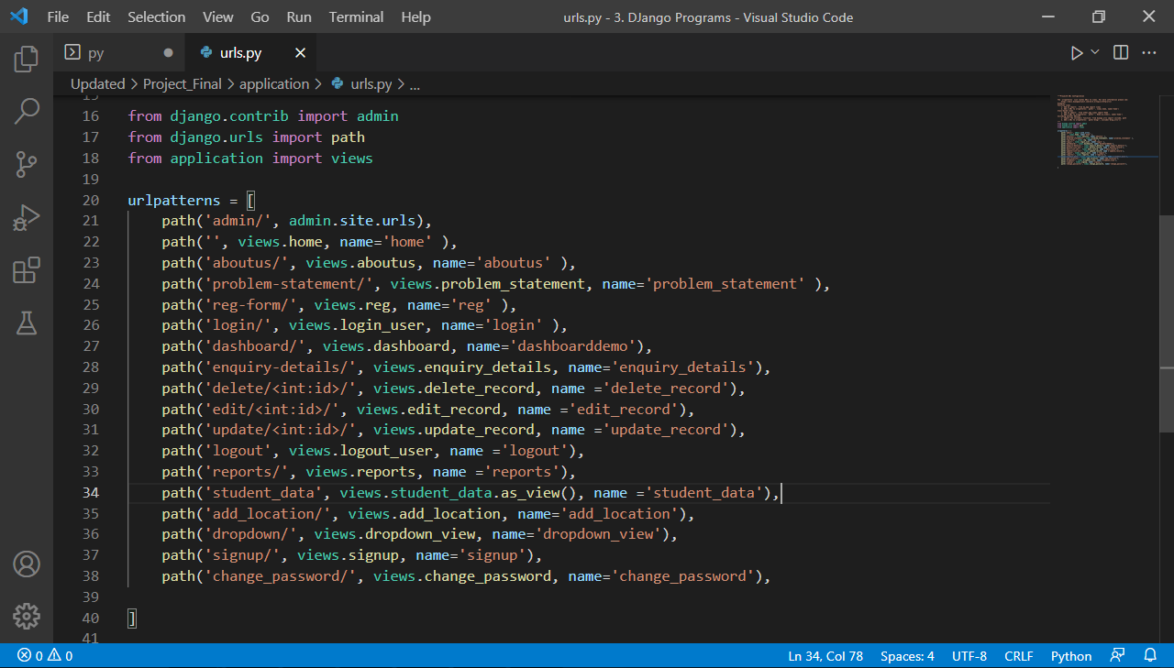

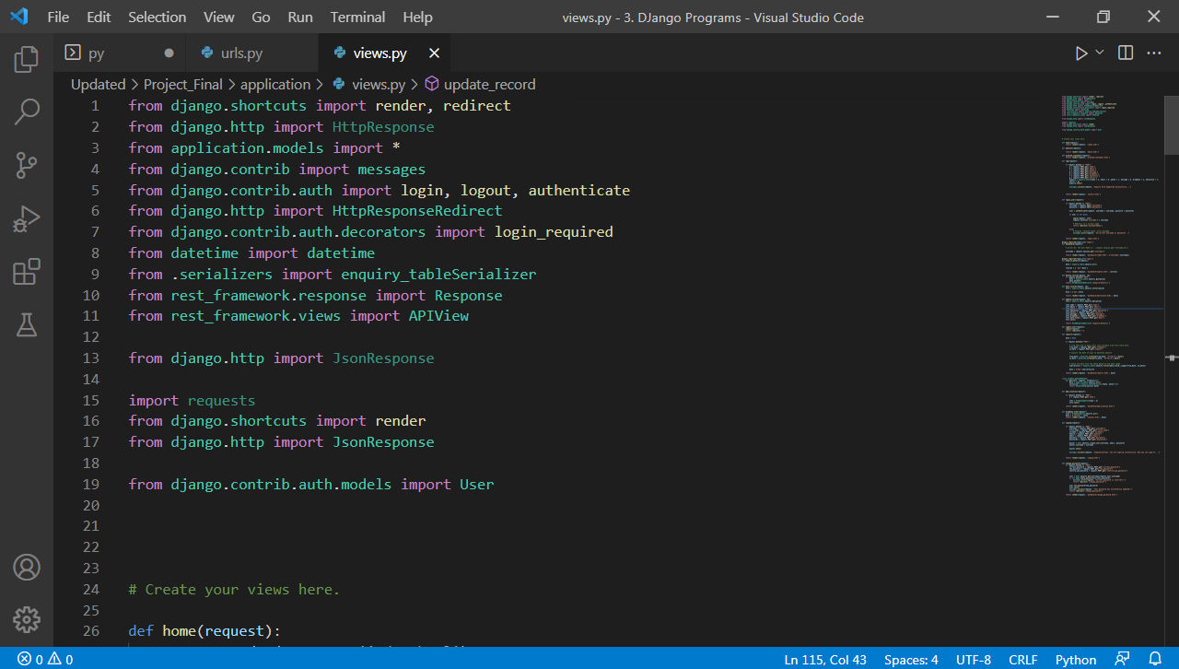

**DJango – Registration Form Inserting into table Code:**

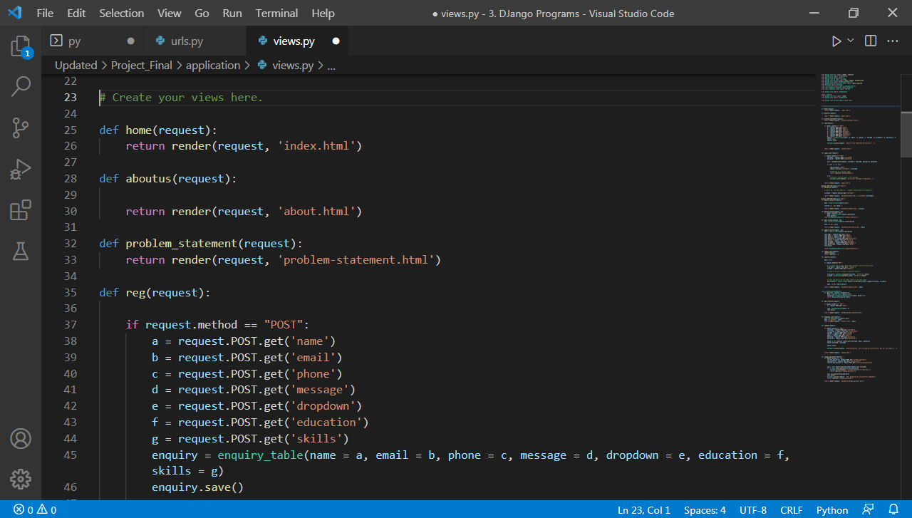

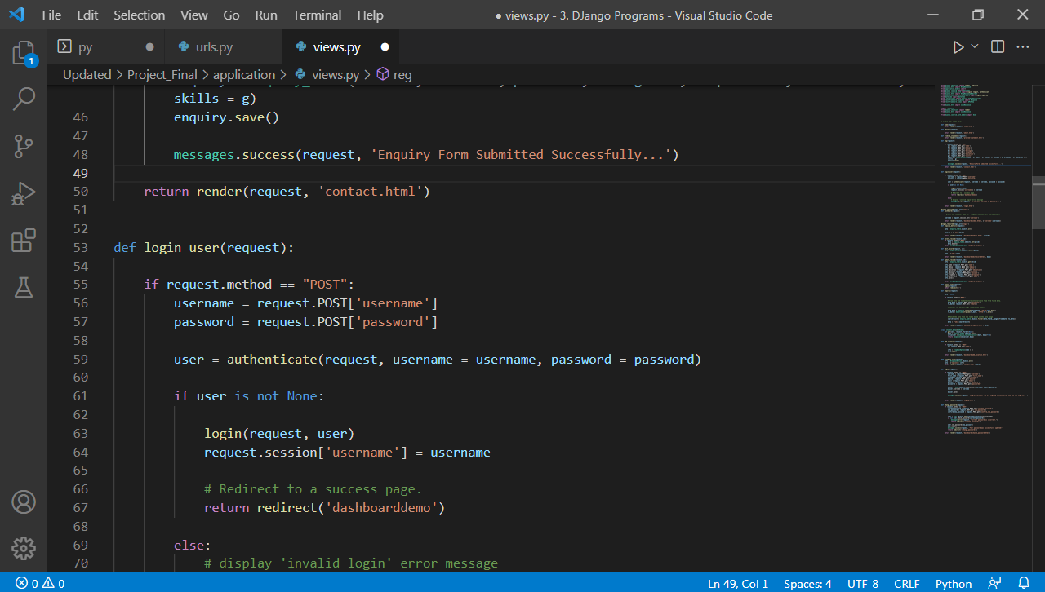

**DJango – Login Authorization Module Code:**

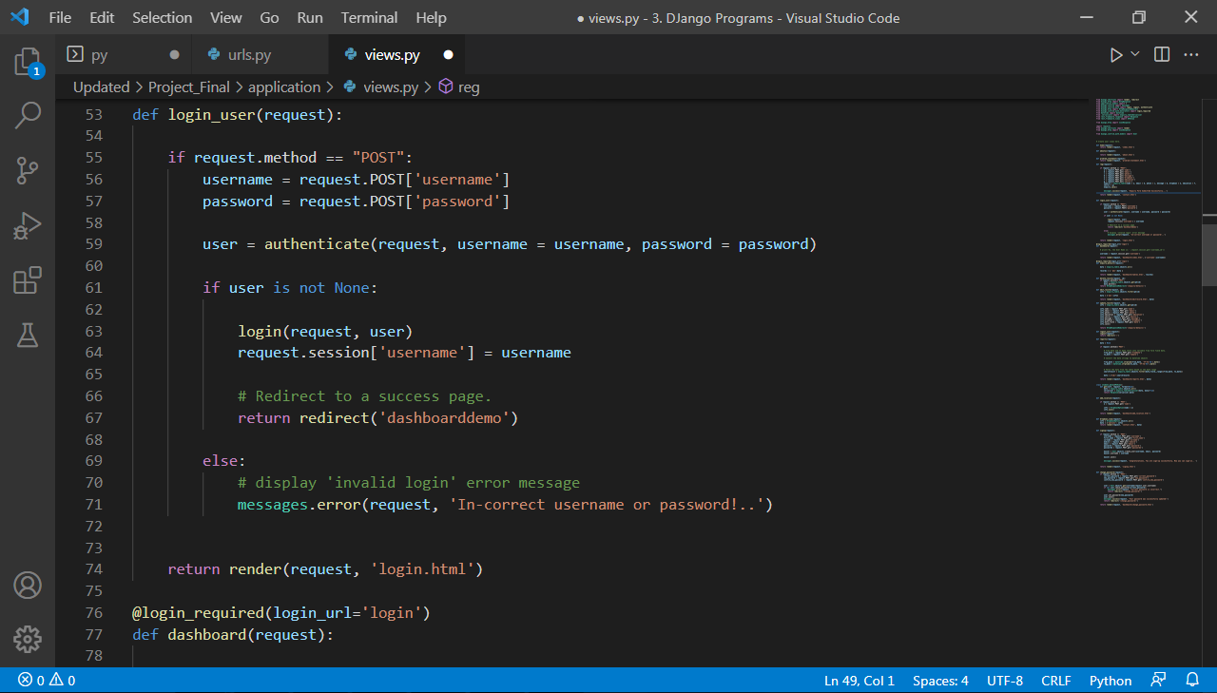

**DJango – Session Maintain, Handling Anonymous User and Delete Record Code:**

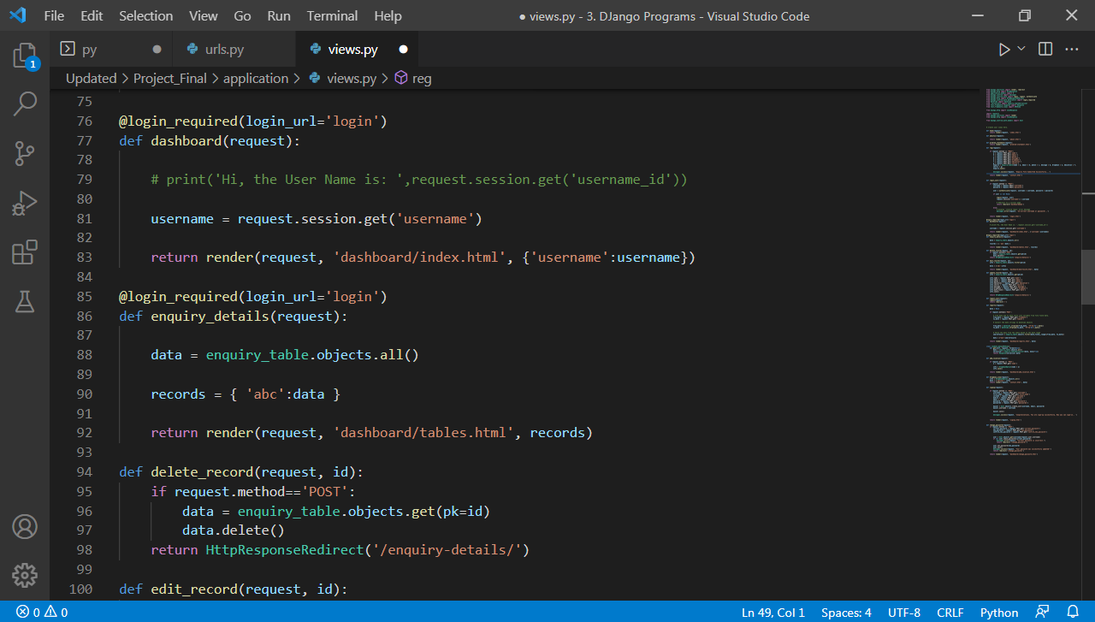

**DJango - Sign-Up User Module Code:**

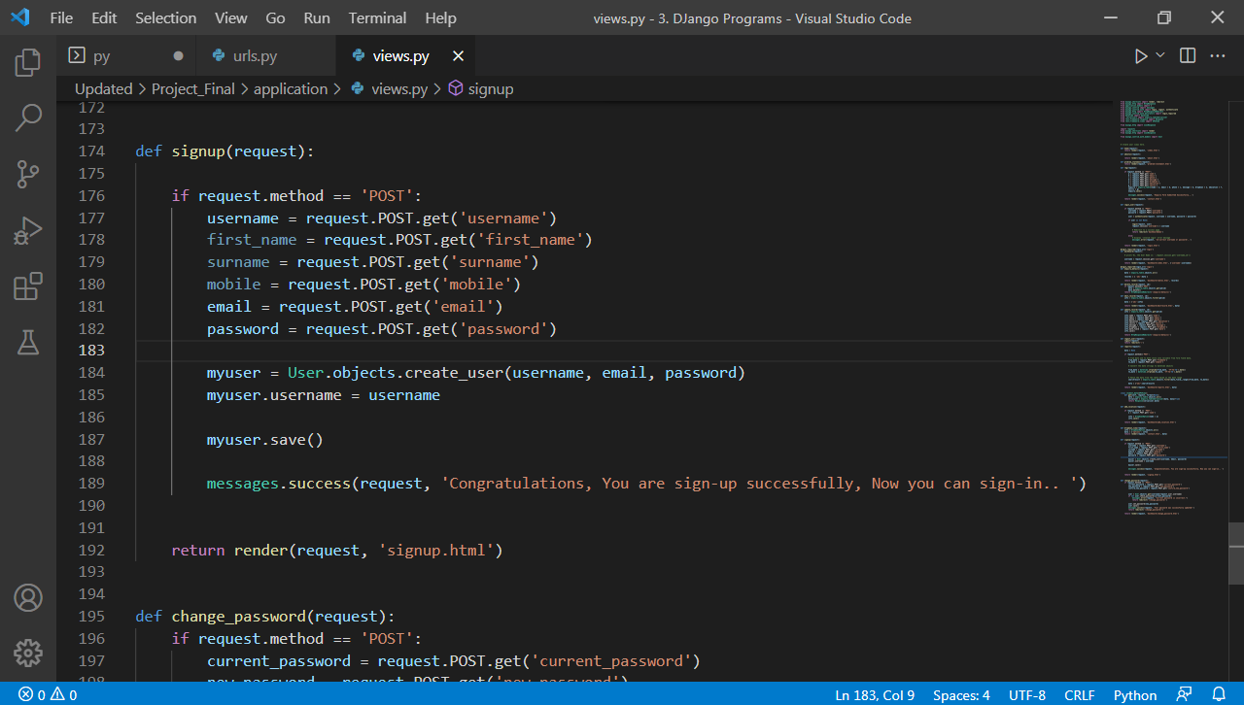

**DJango – Freelancer login authorization Module Code:**

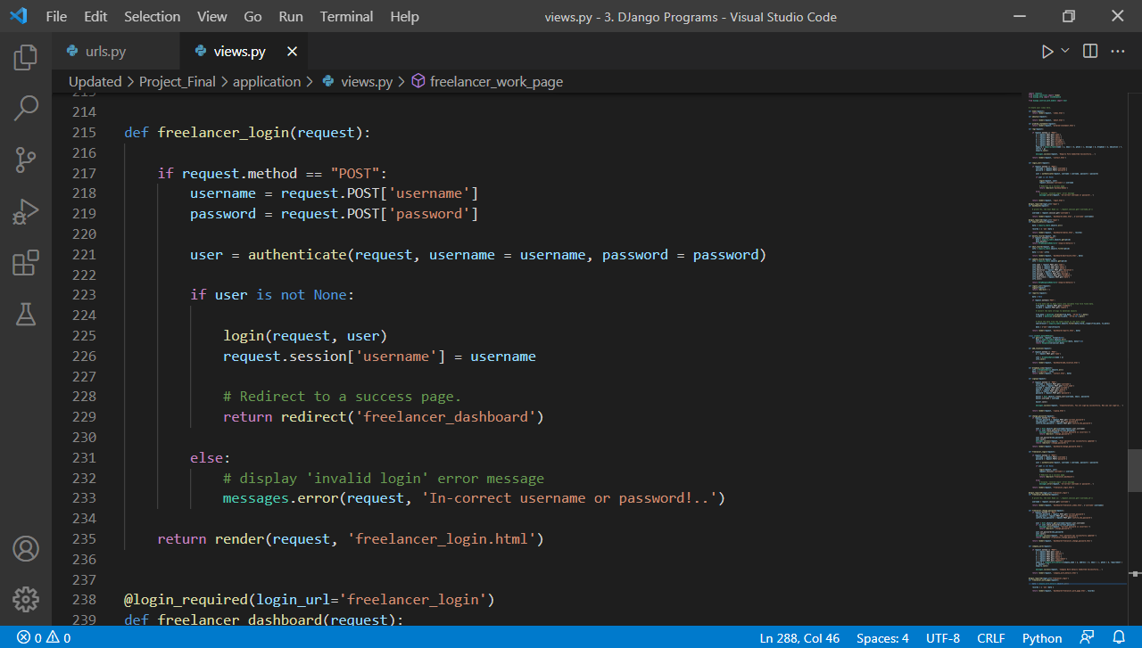

**DJango – Company Work assignment and work display Module Code:**

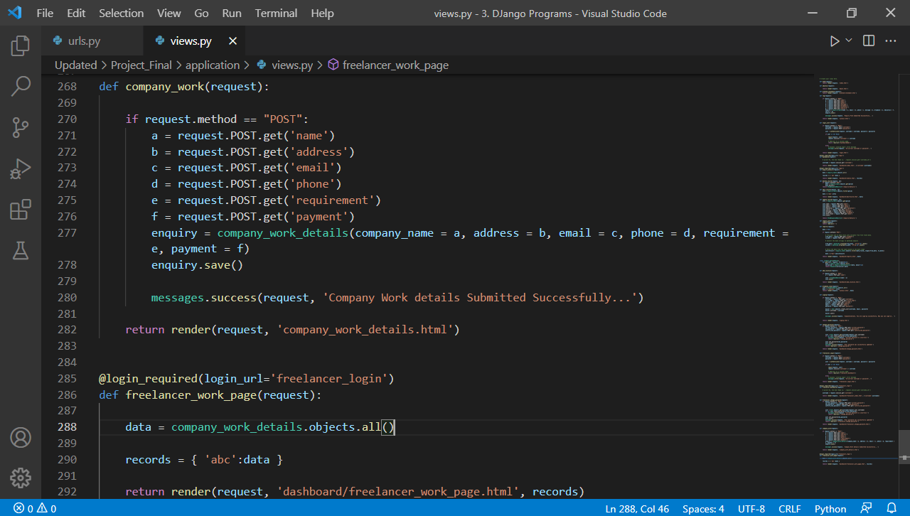

**Test Strategy for Freelancer Housewife Portal:**

### 1. Introduction

The **Freelancer Housewife Portal** is a platform where freelancers (housewives) can register, manage profiles, get assigned tasks, and perform various activities based on their skills. The purpose of this **Test Strategy** is to define the testing approach and methods that will be used to validate the functionality, security, and performance of the system.

### 2. Test Objectives

* **Verify** that all features of the system are functional as per the requirements.
* **Ensure** the system performs efficiently under normal and peak loads.
* **Validate** that the system is secure, with proper authentication and authorization mechanisms.
* **Ensure** that the user interface is intuitive and accessible.
* **Test** for data integrity and that the system handles invalid data inputs gracefully.

### 3. Scope of Testing

#### Functional Testing

* **User Registration and Login**:
  + Test freelancer registration with valid and invalid inputs.
  + Test login functionality for freelancers and admin.
  + Test password encryption and validation.
* **Assignment Management**:
  + Verify creation, assignment, and updates of work assignments.
  + Test assignment status change functionality (e.g., Pending, In Progress, Completed).
* **Profile Management**:
  + Test freelancers’ ability to update their profile details (name, email, skills, etc.).
* **Report Generation**:
  + Verify that admins can generate reports for freelancers and assignments.
* **Email Notifications**:
  + Verify that email notifications are triggered for events like assignment creation and status updates.

#### Non-Functional Testing

* **Performance Testing**:
  + Load testing to ensure the system can handle multiple concurrent users.
  + Stress testing to identify system failure points.
* **Usability Testing**:
  + Verify that the user interface is intuitive and easy to navigate.
  + Test on different devices (mobile and desktop).
* **Security Testing**:
  + Test for vulnerabilities like SQL injection, XSS, and CSRF.
  + Verify that user passwords are securely hashed and stored.
  + Test access control to ensure only authorized users can access specific functionalities.

#### Database Testing

* **Data Integrity**:
  + Verify that the database handles valid data correctly and does not accept invalid data.
  + Check for proper relations between tables (e.g., assignments to freelancers).
* **Backup and Recovery Testing**:
  + Ensure that database backup procedures are working.
  + Test recovery scenarios to verify that the system can recover from failure.

### 4. Types of Testing

#### Unit Testing

* Focus on testing individual functions and components of the backend system (Django views, models, etc.).
* Framework: **Django Test Framework**.

#### Integration Testing

* Focus on testing the interaction between various components, such as:
  + Freelancer profile creation and assignment linking.
  + Admin login and assignment creation functionality.

#### System Testing

* Test the system as a whole to ensure all modules work together as expected.
* Includes all functional and non-functional tests.

#### Regression Testing

* Ensure that new updates or bug fixes do not break the existing functionality.
* Test the complete flow from user registration to work assignment completion.

#### User Acceptance Testing (UAT)

* Involve a sample group of freelancers and admins to ensure the system meets user expectations.
* Focus on the usability and ease of interaction with the system.

### 5. Testing Approach

* **Manual Testing**:
  + Used for UI testing, user interaction flow, and exploratory testing.
  + Involves a human tester performing the test cases and verifying the outcomes.
* **Automated Testing**:
  + Automate repetitive tasks like login/logout functionality, assignment creation, and report generation.
  + Tools: **Selenium**, **Postman** (for API testing), **PyTest** (for Django testing).

### 6. Test Deliverables

* **Test Plan**: Detailed test plan, outlining the test cases and execution schedule.
* **Test Cases**: Comprehensive test cases covering both functional and non-functional aspects.
* **Test Logs**: Detailed logs of the tests conducted, including pass/fail status.
* **Defects Report**: List of issues identified during testing with severity and status.

### 7. Test Environment

* **Development Environment**: Local development machine using **Django** and **SQLite**.
* **Staging Environment**: Server setup similar to production, where the final testing is done.
* **Production Environment**: The live VPS server where the system runs after release.

### 8. Risk and Mitigation

* **Risk**: Slow system performance under heavy load.
  + **Mitigation**: Conduct stress testing, optimize database queries, and implement caching strategies.
* **Risk**: Security vulnerabilities.
  + **Mitigation**: Perform regular security testing and fix vulnerabilities such as SQL injections and Cross-Site Scripting (XSS).

### 9. Exit Criteria

Testing will be considered complete when:

* All critical and high-severity defects have been resolved.
* The system passes all functional, non-functional, and security tests.
* The system meets performance expectations and can handle expected load.
* The client or project stakeholders approve the test results.

### 10. Conclusion

This **Test Strategy** provides a structured approach to ensure the **Freelancer Housewife Portal** meets all functional and non-functional requirements. It emphasizes thorough testing to ensure reliability.

**Unit Test Plan:**

### 1. Introduction

The purpose of this **Unit Test Plan** is to outline the approach for testing individual components and functions of the **Freelancer Housewife Portal**. Unit testing is performed on the smallest testable parts of the system, such as models, views, and individual business logic functions, to ensure that each unit of the system behaves as expected.

### 2. Objective

* **Validate** the functionality of individual units or components of the system (like models, views, and functions).
* **Ensure** that each unit operates correctly under various input conditions.
* **Ensure** that changes or additions do not break existing functionality (via regression testing).

### 3. Scope

This test plan covers unit tests for the backend components of the **Freelancer Housewife Portal**. Specifically, it will include:

* **Models** (database entities and logic).
* **Views** (Django views and their responses).
* **Forms** (validation and processing).
* **Utility Functions** (helper methods or functions).

### 4. Testing Approach

#### Unit Testing Framework

* **Django Test Framework**: A built-in testing framework for Django projects, which integrates seamlessly with Python’s unit testing library.
* **Pytest**: For running test cases more efficiently, especially for complex logic.

#### Test Environment

* **Database**: SQLite for testing (same as production database).
* **Framework**: Django, running locally during development or in a test environment.

### 5. Unit Test Cases

Below are the detailed unit tests for key components of the system:

#### 5.1. Models

##### Freelancer Model

* **Test Case 1**: **Test Freelancer Model Creation**
  + **Objective**: Ensure that a freelancer can be successfully created and saved in the database.
  + **Input**: Create a Freelancer object with valid data (name, email, password, etc.).
  + **Expected Output**: Freelancer object should be stored in the database with the correct attributes.
* **Test Case 2**: **Test Freelancer Email Uniqueness**
  + **Objective**: Ensure that the email for freelancers is unique.
  + **Input**: Try creating two freelancers with the same email.
  + **Expected Output**: The second freelancer creation should fail (raise a unique constraint violation).
* **Test Case 3**: **Test Freelancer Password Hashing**
  + **Objective**: Ensure that the password is hashed before storing.
  + **Input**: Create a Freelancer object and store the password.
  + **Expected Output**: The password should be stored as a hashed value and not as plain text.

##### Assignment Model

* **Test Case 1**: **Test Assignment Creation**
  + **Objective**: Verify that an assignment is created and associated with a freelancer.
  + **Input**: Create an Assignment object, assigning it to a freelancer.
  + **Expected Output**: Assignment should be created with the correct freelancer reference.
* **Test Case 2**: **Test Assignment Status Update**
  + **Objective**: Ensure the assignment status can be updated (e.g., from Pending to Completed).
  + **Input**: Change the status of an Assignment object.
  + **Expected Output**: The assignment status should be updated correctly.

#### 5.2. Views

##### Freelancer Registration View

* **Test Case 1**: **Test Registration with Valid Data**
  + **Objective**: Verify that the registration view creates a freelancer when valid data is provided.
  + **Input**: Submit the registration form with valid freelancer data (name, email, password).
  + **Expected Output**: Freelancer is successfully created, and the response is a redirect to the dashboard.
* **Test Case 2**: **Test Registration with Invalid Data**
  + **Objective**: Ensure the view handles invalid data (e.g., missing fields, invalid email).
  + **Input**: Submit the form with invalid data.
  + **Expected Output**: The view should return an error message, and no freelancer should be created.

##### Freelancer Login View

* **Test Case 1**: **Test Login with Valid Credentials**
  + **Objective**: Ensure that a freelancer can log in with correct credentials.
  + **Input**: Provide valid email and password.
  + **Expected Output**: The user is logged in and redirected to the freelancer dashboard.
* **Test Case 2**: **Test Login with Invalid Credentials**
  + **Objective**: Ensure the system rejects login attempts with invalid credentials.
  + **Input**: Provide an invalid email or password.
  + **Expected Output**: The system returns an error message, indicating that login failed.

#### 5.3. Forms

##### Freelancer Registration Form

* **Test Case 1**: **Test Form Validation with Valid Data**
  + **Objective**: Ensure that the registration form validates correctly with valid data.
  + **Input**: Provide valid data for each field.
  + **Expected Output**: Form should pass validation, and a new freelancer object should be created.
* **Test Case 2**: **Test Form Validation with Invalid Data**
  + **Objective**: Ensure that the registration form does not accept invalid data (e.g., invalid email).
  + **Input**: Provide invalid data (e.g., incorrect email format).
  + **Expected Output**: The form should fail validation and show the appropriate error message.

#### 5.4. Utility Functions

##### Password Hashing Function

* **Test Case 1**: **Test Password Hashing**
  + **Objective**: Ensure that passwords are correctly hashed using Django’s built-in password hashing mechanisms.
  + **Input**: Provide a plain-text password.
  + **Expected Output**: The returned hash should not match the plain-text password but should validate correctly during login.

##### Assignment Due Date Checker

* **Test Case 1**: **Test Assignment Due Date**
  + **Objective**: Ensure that the system can calculate and compare assignment due dates.
  + **Input**: Provide a set of assignments with different due dates.
  + **Expected Output**: The system should identify assignments that are overdue and show the appropriate status.

### 6. Tools and Frameworks

* **Unit Testing Framework**: **Django Test Framework** and **Pytest**.
* **Mocking**: Use **unittest.mock** to mock external dependencies (e.g., email sending).
* **Test Coverage**: Ensure 100% code coverage using tools like **coverage.py**.

### 7. Deliverables

* **Test Case Documentation**: A detailed document listing all unit test cases.
* **Test Results**: Logs and outputs from running the tests (pass/fail).
* **Bug Reports**: A list of defects identified during testing with their severity and status.

### 8. Conclusion

This **Unit Test Plan** ensures that individual components and functions of the **Freelancer Housewife Portal** work correctly in isolation. The plan focuses on testing models, views, forms, utility functions, and interactions to validate that the system behaves as expected

**Acceptance Test Plan:**

### 1. Introduction

The purpose of this **Acceptance Test Plan** is to outline the criteria and approach for verifying the functionality, performance, and usability of the **Freelancer Housewife Portal** before it is accepted for release. This testing phase focuses on validating that the system meets the requirements set by the stakeholders and the business objectives.

### 2. Objective

The primary objectives of the acceptance testing are:

* **Validate** that all business requirements and user stories have been implemented.
* **Ensure** the system operates correctly from an end-user perspective.
* **Verify** that the system is ready for production deployment.
* **Ensure** that any issues identified during testing are fixed and the system is stable.

### 3. Scope

#### Functional Testing

* **Freelancer Registration**: Ensure that freelancers can register successfully using valid details.
* **Freelancer Login**: Validate that freelancers can log in using correct credentials.
* **Profile Management**: Ensure freelancers can update their personal details and skills.
* **Assignment Management**: Verify that assignments can be created, assigned, and updated with proper status changes.
* **Admin Actions**: Ensure admins can manage freelancers, assignments, and generate reports.

#### Non-Functional Testing

* **Performance**: Ensure the system can handle multiple simultaneous users and does not experience crashes or delays.
* **Usability**: Ensure the system is intuitive and user-friendly for both freelancers and admins.
* **Security**: Validate that the system is secure, protecting user data and preventing unauthorized access.

#### Data Integrity

* Verify that data is correctly stored, retrieved, and manipulated (e.g., freelancer profiles, assignment data).
* Ensure there is no data loss during system interaction.

### 4. Testing Approach

#### 4.1. Test Types

##### Functional Acceptance Testing

* **Registration**: Test freelancer registration with valid and invalid data.
* **Login**: Ensure both freelancers and admins can log in successfully with valid credentials.
* **Profile Update**: Validate that freelancers can update their profiles (name, email, skills, etc.).
* **Assignment Creation**: Ensure that assignments can be created and assigned to freelancers.
* **Admin Report Generation**: Verify that the admin can generate accurate reports for freelancers and assignments.

##### Non-Functional Acceptance Testing

* **Performance Testing**: Ensure that the system can handle a realistic number of concurrent users without significant delays.
* **Usability Testing**: Perform end-user testing to verify that the user interface is easy to navigate and intuitive.
* **Security Testing**: Test for vulnerabilities, ensuring that user data is protected and no unauthorized users can access sensitive data.

##### Data Integrity Testing

* **Database Accuracy**: Validate that all data (freelancer profiles, assignments, etc.) is accurately stored and retrieved from the database.
* **Data Validation**: Ensure that incorrect or invalid data (e.g., invalid email format) is rejected by the system.

### 5. Acceptance Criteria

Acceptance criteria are the conditions that must be met for the system to be considered acceptable to stakeholders.

#### 5.1. Functional Acceptance Criteria

* **Registration**: Freelancers can register with valid data, and their details are correctly stored in the system.
* **Login**: Freelancers and admins can log in using valid credentials and are redirected to their respective dashboards.
* **Profile Management**: Freelancers can update their profiles with valid information (name, email, phone, etc.).
* **Assignments**: Freelancers can view assigned tasks, and admins can assign tasks to freelancers.
* **Admin Reports**: Admins can generate reports, showing accurate and up-to-date information.

#### 5.2. Non-Functional Acceptance Criteria

* **Performance**: The system can handle at least 100 concurrent users without degradation in performance.
* **Usability**: Users can navigate the portal without confusion, and all main features are accessible within 3 clicks.
* **Security**: The system passes basic security tests (e.g., no SQL injection vulnerabilities, correct user authentication/authorization).

#### 5.3. Data Integrity Criteria

* **Accuracy**: All freelancer data (profile, assignments) is correctly saved and retrieved.
* **Error Handling**: The system displays appropriate error messages for invalid data (e.g., incorrect email format).
* **Backup and Recovery**: Data is correctly backed up and can be restored in case of a failure.

### 6. Test Deliverables

* **Test Cases and Results**: A document listing all the test cases executed during acceptance testing along with their results (pass/fail).
* **Defect Report**: A log of any defects found during testing, including severity, status, and steps for reproduction.
* **Test Summary Report**: A report summarizing the testing activities, results, and any issues encountered during testing.
* **Acceptance Sign-off**: A formal sign-off document from the project stakeholders confirming that the system meets all acceptance criteria.

### 7. Test Environment

* **Staging Environment**: The system will be tested in an environment that mirrors production, ensuring that the final system is tested in real-world conditions.
* **Testing Tools**:
  + Performance testing tools: **JMeter** or **LoadRunner**.
  + Usability testing: Conducted with real users in a controlled environment.
  + Security testing: **OWASP ZAP** or other security tools for vulnerability assessment.

### 8. Schedule and Timeline

Acceptance testing will take place over a period of 5 to 7 days. The following is the proposed timeline:

* **Day 1-2**: Functional testing (registration, login, profile management).
* **Day 3**: Assignment management testing and admin actions.
* **Day 4**: Performance testing and usability testing.
* **Day 5**: Security testing, data integrity testing, and backup/recovery verification.
* **Day 6-7**: Review of test results, defect fixing, and final sign-off from stakeholders.

### 9. Roles and Responsibilities

* **QA Team**: Responsible for executing all test cases and logging defects.
* **Project Manager**: Ensures that the project meets acceptance criteria and tracks testing progress.
* **Developers**: Address defects identified during testing and provide fixes.
* **Stakeholders**: Review the acceptance results and sign off on the final release.

### 10. Exit Criteria

The system will be accepted if:

* All high-priority functional requirements have passed acceptance testing.
* No critical or high-severity defects remain unresolved.
* Performance benchmarks are met.
* The system passes security and data integrity testing.

If these conditions are not met, the system will not be accepted, and the necessary changes or fixes will be implemented before retesting.

### 11. Conclusion

This **Acceptance Test Plan** ensures that the **Freelancer Housewife Portal** meets all business and technical requirements before it is deployed to production. The goal is to verify that the system is ready for use by freelancers and admins and that it performs securely, efficiently, and with high usability.

# **T**est **C**ases

### 1. Housewife Registration Form

| **Test Case ID** | **Test Scenario** | **Test Steps** | **Expected Result** |
| --- | --- | --- | --- |
| TC_RF_01 | Validate mandatory fields | Leave all fields blank and click Submit | Error messages should appear for all required fields |
| TC_RF_02 | Validate successful registration | Fill in valid details and submit | Registration successful message or redirect to login |
| TC_RF_03 | Validate duplicate email | Register with an email already used | System should show "Email already exists" error |
| TC_RF_04 | Validate field validation | Enter invalid data (e.g., letters in phone number) | Appropriate error messages should appear |

### 2. Signup Form

| **Test Case ID** | **Test Scenario** | **Test Steps** | **Expected Result** |
| --- | --- | --- | --- |
| TC_SF_01 | Validate signup with valid data | Fill in correct details and signup | User account should be created successfully |
| TC_SF_02 | Validate password strength | Enter weak passwords | System should enforce strong password rules |
| TC_SF_03 | Validate mandatory fields | Leave mandatory fields empty | Appropriate validation error should appear |
| TC_SF_04 | Validate email format | Enter invalid email format | Should display "Invalid email format" message |

### 3. Admin Login

| **Test Case ID** | **Test Scenario** | **Test Steps** | **Expected Result** |
| --- | --- | --- | --- |
| TC_AL_01 | Validate login with valid credentials | Enter valid username and password | Admin dashboard should open |
| TC_AL_02 | Validate login with invalid credentials | Enter wrong username/password | Error message like "Invalid login details" |
| TC_AL_03 | Validate empty fields | Keep username/password fields empty | System should prompt "Please fill in all fields" |

### 4. Admin Fetch Registration Records

| **Test Case ID** | **Test Scenario** | **Test Steps** | **Expected Result** |
| --- | --- | --- | --- |
| TC_AR_01 | Fetch all records | Navigate to registration records page | List of all registered housewives displayed |
| TC_AR_02 | Validate sorting/filtering (if available) | Apply sort/filter options | Records should update according to selection |
| TC_AR_03 | Validate no records scenario | No registrations exist | "No records found" message should appear |

### 5. Report Generation

| **Test Case ID** | **Test Scenario** | **Test Steps** | **Expected Result** |
| --- | --- | --- | --- |
| TC_RG_01 | Generate report for all users | Click Generate Report | System should generate and download/export report |
| TC_RG_02 | Validate report format | Open generated report | Report should have correct columns and data |
| TC_RG_03 | Validate report with filters (if applicable) | Apply date range/filters before generating report | Report should match filter conditions |

### 6. Change Password

| **Test Case ID** | **Test Scenario** | **Test Steps** | **Expected Result** |
| --- | --- | --- | --- |
| TC_CP_01 | Change password successfully | Enter correct old password and new password | Password updated successfully |
| TC_CP_02 | Incorrect old password | Enter wrong old password | System should show "Old password incorrect" |
| TC_CP_03 | Validate password confirmation | New password and Confirm password mismatch | System should show "Passwords do not match" error |

### 7. Freelancer Login

| **Test Case ID** | **Test Scenario** | **Test Steps** | **Expected Result** |
| --- | --- | --- | --- |
| TC_FL_01 | Login with valid freelancer credentials | Enter valid email and password | Freelancer dashboard should open |
| TC_FL_02 | Login with invalid credentials | Enter wrong email/password | "Invalid login credentials" error shown |
| TC_FL_03 | Validate empty fields on login | Leave email/password blank | "Please fill all fields" message shown |
| TC_FL_04 | Validate inactive freelancer login (optional) | Try to login with deactivated account | System should block login with appropriate message |

### 8. Company Work Assignment Data (Freelancer View)

| **Test Case ID** | **Test Scenario** | **Test Steps** | **Expected Result** |
| --- | --- | --- | --- |
| TC_WA_01 | View assigned work after login | Login as freelancer and navigate to 'My Work' section | List of assigned works shown with details (title, description, deadline, status) |
| TC_WA_02 | Validate no work assigned | Login as freelancer with no work assigned | Message: "No assignments available yet" |
| TC_WA_03 | View detailed assignment information | Click on an assignment | Full assignment details open (description, files if any, deadline) |
| TC_WA_04 | Validate assignment status update (if applicable) | Mark an assignment as completed (if feature exists) | Status should update to "Completed" |
| TC_WA_05 | Validate access control | Freelancer tries to access another freelancer's work data via URL | Access should be denied with "Unauthorized access" message |

# **Limitations of Proposed System:**

### 1. Limited Support for Advanced Search and Filtering

* The portal may not support advanced search and filtering options for freelancers and assignments. As a result, users may face difficulty in quickly finding specific freelancers based on their skills, experience, or location.

### 2. Lack of Integration with External Platforms

* The portal does not integrate with third-party platforms (e.g., job boards, social media, or project management tools). This could limit the exposure of freelancers and restrict their ability to get external assignments or projects from other platforms.

### 3. Limited Payment Processing Features

* The proposed system does not include an integrated payment gateway. Freelancers may need to handle payments externally, which could be inconvenient and lead to trust issues between freelancers and employers. In the future, adding an integrated payment system like PayPal or Stripe could enhance the user experience.

### 4. Minimal Reporting Capabilities

* The portal may offer only basic reporting features (e.g., freelancer profiles, assignments, and work progress). It lacks more advanced reporting options that could be beneficial for both freelancers and employers, such as financial reports, productivity analytics, and performance insights.

### 5. Scalability Challenges

* As the portal is designed with basic functionality, scaling it to accommodate a large number of users (both freelancers and employers) could require significant adjustments. The current architecture, using SQLite as the database, may not handle high traffic efficiently, and a migration to a more robust database like PostgreSQL or MySQL may be necessary in the future.

### 6. User Authentication Limitations

* The current user authentication system relies on basic username/password login. It lacks advanced security features like multi-factor authentication (MFA), which could improve security for both freelancers and employers. Adding MFA or OAuth login options (Google, Facebook, etc.) could enhance security and convenience.

### 7. No Mobile App or Mobile-Responsive Design

* The portal does not have a dedicated mobile application. While it is accessible via a web browser, the lack of a mobile app or mobile-responsive design may hinder freelancers' ability to manage assignments and profiles on the go. This limitation could reduce user engagement, especially among housewives with limited access to desktop computers.

### 8. Lack of Inbuilt Communication Tools

* The system does not have built-in communication features (e.g., messaging or chat functionality) between freelancers and employers. Currently, freelancers and employers may need to use external tools (e.g., email or phone) to communicate, which could lead to inefficiencies and missed opportunities for collaboration.

### 9. Limited Admin Features

* The admin interface is basic and may not provide enough tools for more advanced administrative tasks, such as bulk assignment management, user analytics, and detailed workflow automation. Expanding the admin capabilities would provide better control over the platform.

### 10. No Built-in Feedback System

* The portal lacks a built-in feedback or rating system, which would allow freelancers to receive feedback from employers and vice versa. Implementing such a system could build trust and provide valuable insights into the quality of freelancers’ work.

# **Proposed Enhancements:**

### 1. Advanced Search and Filtering

* **Enhancement**: Implement advanced search and filtering options to allow freelancers and employers to easily search for and filter assignments or freelancers based on specific criteria such as skills, experience, location, and availability.
* **Benefit**: This will enhance the user experience, making it easier for both freelancers and employers to find the right match quickly.

### 2. Integration with External Platforms

* **Enhancement**: Integrate the portal with external job boards (e.g., LinkedIn, Indeed) and project management tools (e.g., Trello, Asana) to provide freelancers with access to a wider range of assignments and to streamline the assignment management process.
* **Benefit**: This will increase the portal’s exposure and provide more opportunities for freelancers, while employers can use their existing tools to manage projects more efficiently.

### 3. Integrated Payment Gateway

* **Enhancement**: Implement an integrated payment system, such as PayPal, Stripe, or Razorpay, to facilitate secure payments between freelancers and employers.
* **Benefit**: This will simplify the payment process, reduce friction, and build trust between freelancers and employers by handling transactions within the platform.

### 4. Advanced Reporting Features

* **Enhancement**: Enhance reporting capabilities for both freelancers and employers, including financial reports, performance metrics, assignment progress tracking, and productivity analytics.
* **Benefit**: This will provide more valuable insights and help users track their progress, income, and project performance, improving overall decision-making.

### 5. Scalability Improvements

* **Enhancement**: Migrate to a more robust database, such as PostgreSQL or MySQL, and implement a scalable server infrastructure to handle higher traffic volumes.
* **Benefit**: This will allow the portal to scale more effectively as the user base grows, ensuring faster response times and preventing performance bottlenecks.

### 6. Enhanced User Authentication and Security

* **Enhancement**: Implement multi-factor authentication (MFA) and/or OAuth integration (Google, Facebook) for a more secure and user-friendly login process.
* **Benefit**: This will increase security, protect user data, and reduce the risk of unauthorized access, giving both freelancers and employers peace of mind.

### 7. Mobile App and Mobile-Responsive Design

* **Enhancement**: Develop a mobile app or implement a mobile-responsive design that enables freelancers and employers to access the portal on their smartphones and tablets.
* **Benefit**: This will improve accessibility, allowing users to manage assignments, update profiles, and communicate on the go, leading to increased user engagement.

### 8. Inbuilt Communication Tools

* **Enhancement**: Integrate messaging and chat features directly within the portal to allow freelancers and employers to communicate in real-time without relying on external tools.
* **Benefit**: This will streamline communication, reduce delays, and enhance collaboration between freelancers and employers.

### 9. Enhanced Admin Features

* **Enhancement**: Expand the admin panel to support more advanced features, such as bulk user management, detailed analytics, automatic report generation, and advanced workflow automation.
* **Benefit**: This will provide administrators with more control over the platform, improve system management, and automate routine tasks.

### 10. Built-in Feedback and Rating System

* **Enhancement**: Implement a feedback and rating system that allows freelancers to rate employers and vice versa after each assignment is completed.
* **Benefit**: This will help build trust within the platform, encourage better work quality, and provide valuable insights to both freelancers and employers.

### 11. Support for Multiple Payment Models

* **Enhancement**: Implement support for different payment models, such as hourly rates, fixed-price contracts, and milestone-based payments.
* **Benefit**: This will give both freelancers and employers more flexibility when negotiating and agreeing on payment terms.

### 12. Mobile App Development

* **Enhancement**: Create a dedicated mobile app for iOS and Android that allows users to manage profiles, assignments, and communicate with employers and freelancers.
* **Benefit**: This will increase accessibility and user engagement by offering a native mobile experience.

### 13. Internationalization (I18N) Support

* **Enhancement**: Add support for multiple languages to make the platform accessible to a broader, global audience.
* **Benefit**: This will expand the reach of the platform and enable users from different linguistic backgrounds to use the portal, thereby increasing the user base.

### 14. AI/ML-Based Skill Matching

* **Enhancement**: Introduce machine learning or AI-based algorithms to automatically match freelancers with suitable assignments based on their skills, experience, and availability.
* **Benefit**: This will improve the efficiency of matching freelancers with projects and reduce the manual effort required by both freelancers and employers to find suitable work.

### 15. Customizable Freelancer Profiles

* **Enhancement**: Allow freelancers to create more detailed profiles that include a portfolio of past work, certifications, and reviews from previous employers.
* **Benefit**: This will enable freelancers to showcase their skills and work more effectively, increasing their chances of being hired by employers.

# **M**ethodological **D**etails

# **Needs Assessment:** The program begins with a needs assessment to determine the participants' learning requirements and objectives. A pre-internship survey and individual interviews with participants are used to determine their expectations, aspirations, and past knowledge.

# **The theoretical lectures:** that address the principles of web development, Python programming, and the Django framework. These workshops are led by expert trainers who employ a variety of instructional techniques, including lectures, demonstrations, and interactive discussions. The workshops give learners a thorough foundation of web development concepts and techniques, as well as the Django framework.

# **Practical tasks:** The program contains practical tasks that allow learners to apply what they've learned in the classroom to real-world settings. The tasks are intended to reinforce theoretical principles while also providing practical experience with Python and the Django framework. Depending on the nature of the task, the assignments are performed either independently or in groups.

# **Hands-on Projects:** The program includes hands-on projects that provide learners the opportunity to work on real-world web development projects. The projects are meant to imitate real-world problems and allow participants to apply their knowledge in a practical environment. Depending on the nature of the project, projects are performed either alone or in groups.

# **Mentorship & Support:** Throughout the internship, participants will get mentorship and support from the program. Each participant is allocated a mentor who will provide direction, support, and feedback on their assignments and projects. Participants can also ask trainers and mentors for help via email, online forums, or one-on-one meetings.

# **Assessment and Evaluation:** The program includes assessments and evaluations to track learning outcomes and internship effectiveness. Practical assignments, hands-on projects, and online quizzes are used to assess participants. The assessments are carried out using feedback questionnaires and participant interviews to identify the program's strengths and flaws as well as possibilities for development.

# **C**onclusion

The **Freelancer Housewife Portal** is designed to empower housewives by providing them with a platform to showcase their skills, manage assignments, and collaborate with employers. While the current system offers essential features such as registration, login, profile management, and assignment handling, there are several limitations that can hinder its scalability, user experience, and functionality.

The **proposed enhancements** aim to address these limitations and elevate the platform to the next level. By integrating advanced search features, expanding reporting capabilities, adding a secure payment gateway, improving mobile access, and introducing communication tools, the portal can become more user-friendly, efficient, and secure. Additionally, introducing AI-based matching, multi-payment models, and multilingual support will broaden the portal's reach and appeal to a global audience.

Implementing these enhancements will not only improve the platform's usability and performance but also ensure that it remains relevant and competitive in the ever-evolving landscape of freelancing platforms. With these improvements, the **Freelancer Housewife Portal** has the potential to offer a richer, more engaging experience for freelancers and employers, fostering trust and enabling long-term success for both parties.

# **B**ibliography

· **Django Documentation**  
Django Software Foundation. (2025). *Django Documentation*. Retrieved from <https://docs.djangoproject.com>

· **SQLite Documentation**  
SQLite Consortium. (2025). *SQLite Documentation*. Retrieved from https://www.sqlite.org/docs.html

· **Python Official Documentation**  
Python Software Foundation. (2025). *Python Documentation*. Retrieved from <https://docs.python.org>

· **OWASP Security Testing Guide**  
OWASP Foundation. (2025). *OWASP Security Testing Guide*. Retrieved from https://owasp.org/www-project-top-ten/

· **W3C Mobile Web Best Practices**  
World Wide Web Consortium (W3C). (2025). *Mobile Web Best Practices*. Retrieved from <https://www.w3.org/TR/mwbp/>

1. <https://www.python.org/downloads/>
2. <https://www.djangoproject.com/>
3. <https://realpython.com/tutorials/web-dev/>
4. <https://cpanel.net/>
5. <https://bootstrapstudio.io/>
6. https://getbootstrap.com

# **A**nnexure

The **Annexure** section typically includes supplementary material, such as diagrams, code snippets, sample data, or any additional information that supports the main content of the report or documentation. Below is an example structure for the **Annexure** of the **Freelancer Housewife Portal** project.

### Annexure A: Sample User Interface Screenshots

1. **Freelancer Registration Form**  
   A screenshot of the freelancer registration form showing required fields for user details such as name, email, skill set, and experience.
2. **Employer Dashboard**  
   A screenshot showing the employer dashboard, where they can post new assignments, view available freelancers, and manage existing assignments.
3. **Freelancer Profile**  
   A screenshot of the freelancer profile page with sections for skills, experience, portfolio, and assignment history.
4. **Admin Dashboard**  
   A screenshot of the admin dashboard that includes features for managing users, assignments, and generating reports.

### Annexure B: Sample Database Schema

#### Table: Freelancer

| **Column Name** | **Data Type** | **Description** |
| --- | --- | --- |
| freelancer_id | INTEGER | Primary Key, Unique Freelancer ID |
| first_name | TEXT | First Name |
| last_name | TEXT | Last Name |
| email | TEXT | Freelancer Email |
| password | TEXT | Hashed Password |
| skills | TEXT | List of Skills |
| experience | TEXT | Years of Experience |
| profile_picture | BLOB | Freelancer Profile Picture |

#### Table: Assignment

| **Column Name** | **Data Type** | **Description** |
| --- | --- | --- |
| assignment_id | INTEGER | Primary Key, Unique Assignment ID |
| title | TEXT | Title of the Assignment |
| description | TEXT | Description of the Assignment |
| deadline | DATE | Deadline for the Assignment |
| status | TEXT | Status of the Assignment (Open, Closed, In-progress) |
| employer_id | INTEGER | Foreign Key, Links to Employer |
| freelancer_id | INTEGER | Foreign Key, Links to Freelancer |

### Annexure C: Code Snippets

#### 1. Django Model for Freelancer

python

CopyEdit

from django.db import models

class Freelancer(models.Model):

first_name = models.CharField(max_length=100)

last_name = models.CharField(max_length=100)

email = models.EmailField(unique=True)

password = models.CharField(max_length=200) # Hashed password

skills = models.TextField()

experience = models.TextField()

profile_picture = models.ImageField(upload_to='profile_pics/', null=True, blank=True)

def __str__(self):

return f"{self.first_name} {self.last_name}"

#### 2. Django Model for Assignment

python

CopyEdit

from django.db import models

class Assignment(models.Model):

title = models.CharField(max_length=255)

description = models.TextField()

deadline = models.DateField()

status = models.CharField(max_length=50, choices=[('Open', 'Open'), ('In-progress', 'In-progress'), ('Closed', 'Closed')])

employer = models.ForeignKey('Employer', on_delete=models.CASCADE)

freelancer = models.ForeignKey('Freelancer', on_delete=models.SET_NULL, null=True, blank=True)

def __str__(self):

return self.title

### Annexure D: Sample JSON Data for API Testing

#### Freelancer Registration

json

CopyEdit

{

"first_name": "John",

"last_name": "Doe",

"email": "johndoe@example.com",

"password": "hashed_password_here",

"skills": "Python, Django, Web Development",

"experience": "3 years",

"profile_picture": "profile_pic_url"

}

#### Assignment Data

json

CopyEdit

{

"title": "Web Development Project",

"description": "Build a responsive website for a small business.",

"deadline": "2025-06-01",

"status": "Open",

"employer_id": 1,

"freelancer_id": null

}

### Annexure E: Test Case Examples

1. **Test Case 1: Freelancer Registration**
   * **Test Objective**: Verify that a freelancer can register successfully with valid information.
   * **Test Steps**:
     1. Navigate to the freelancer registration page.
     2. Fill in valid details (name, email, skills, experience).
     3. Submit the registration form.
   * **Expected Result**: The freelancer’s account is created, and a confirmation message is displayed.
2. **Test Case 2: Employer Posting an Assignment**
   * **Test Objective**: Verify that an employer can post a new assignment successfully.
   * **Test Steps**:
     1. Log in as an employer.
     2. Navigate to the 'Post Assignment' page.
     3. Enter assignment details (title, description, deadline).
     4. Submit the assignment.
   * **Expected Result**: The assignment is listed on the platform, and freelancers are notified.

### Annexure F: Glossary of Terms

* **Freelancer**: A person who offers their services for specific projects or tasks.
* **Employer**: A person or company who posts assignments and hires freelancers.
* **Assignment**: A job or project posted by an employer that a freelancer can apply for.
* **Admin**: The user with the highest level of access who manages the portal, users, and assignments.

This **Annexure** section provides supplementary details that support the main content of the project report, including UI screenshots, code snippets, sample data, and testing information.